# **Introduction to GIS concepts**

* + Definition of GIS.

Geographic Information System (GIS) is a technology that captures, stores, analyzes, and visualizes spatial and geographic data, allowing users to explore relationships, patterns, and trends on Earth’s surface to support decision-making across various fields. GIS can at times become abstract to fit the definitions below:

GIS as a Science and Art:

Geographic Information System (GIS) is both a science and an art focused on understanding spatial and geographic patterns. It involves the study of spatial relationships, geographical phenomena, and the creative interpretation of spatial data to analyze how physical and social processes interact across space. This scientific and artistic approach in GIS enables the visualization, analysis, and interpretation of complex spatial information to support insight into environmental, societal, and cultural patterns.

GIS as Technology (Hardware and Software):

Geographic Information System (GIS) is a technological system composed of hardware and software used for capturing, storing, analyzing, and displaying geographic data. The hardware consists of computers, servers, GPS devices, and other tools that facilitate data collection and processing. The software includes specialized GIS applications that enable users to manage spatial databases, perform complex spatial analyses, and create detailed maps. This technology allows for efficient data handling, visualization, and geographic analysis, supporting a range of applications across industries.

Importance and applications of GIS.

GIS is essential because it provides a unique perspective on data through the lens of location, making it possible to identify patterns, relationships, and trends that are difficult to see otherwise. This spatial perspective enhances decision-making in various fields, promotes efficient resource allocation, and aids in planning and managing the environment, infrastructure, and public services. GIS enables better communication through visualizations, supports problem-solving with data-driven insights, and fosters collaboration across disciplines by providing a common framework.

**Applications of GIS:**

1. **Urban Planning and Development**: GIS is used to analyze land use, assess zoning compliance, design transportation networks, and monitor urban growth to make informed development plans.
2. **Environmental Management**: GIS helps track and manage natural resources, assess environmental impacts, monitor wildlife habitats, and plan conservation efforts, aiding in sustainable environmental practices.
3. **Disaster Management**: GIS is crucial in risk assessment, emergency response, and recovery by mapping hazard zones, predicting disaster impact, and coordinating rescue operations.
4. **Public Health**: GIS enables the mapping and analysis of disease outbreaks, healthcare accessibility, and health resource allocation, allowing for better responses to public health challenges.
5. **Agriculture**: In agriculture, GIS supports precision farming by analyzing soil conditions, weather patterns, and crop health, leading to optimized resource use and increased yields.
6. **Transportation and Logistics**: GIS assists in route planning, traffic management, and infrastructure maintenance, improving efficiency and reducing costs in logistics and transportation.
7. **Natural Resource Management**: GIS supports the exploration and management of resources such as minerals, oil, gas, and water by mapping resource locations and analyzing geological data.
8. **Real Estate and Market Analysis**: GIS provides insights into property values, market demographics, and spatial trends, benefiting real estate development and retail site selection.
9. **Utilities Management**: GIS is used by utility companies to manage infrastructure such as water, gas, and electric networks, helping to optimize maintenance and manage assets.
10. **Education and Research**: GIS is widely used in academia and research for spatial analysis, enabling scientists to conduct studies in fields like ecology, geography, sociology, and archaeology.

Key components of GIS.

The key components of GIS are essential elements that work together to collect, store, analyze, and visualize geographic data effectively. These components include:

1. **Hardware**:  
   The physical technology that runs GIS software, such as computers, servers, GPS devices, and mobile devices. Hardware facilitates data processing, storage, and output in various formats, including maps, reports, and digital displays.
2. **Software**:  
   GIS software provides the tools needed for data entry, analysis, visualization, and management. Examples include ArcGIS, QGIS, and Google Earth. Software is responsible for data processing, mapping, spatial analysis, and creating user interfaces for interaction with spatial data.
3. **Data**:  
   The core of any GIS, data includes geographic (spatial) and attribute (non-spatial) information. Spatial data describes the location and shape of features (such as points, lines, and polygons), while attribute data provides descriptive information about those features (such as population or land use). Data sources can be diverse, including satellite imagery, GPS data, surveys, and existing databases.
4. **People**:  
   Users and professionals who operate GIS systems, analyze data, and apply the information in real-world scenarios. GIS professionals include GIS analysts, cartographers, data scientists, and decision-makers who interpret and utilize spatial data to solve problems and make decisions.
5. **Methods**:  
   The procedures, techniques, and workflows used to collect, process, analyze, and interpret spatial data within a GIS. These methodologies ensure that GIS analyses are conducted accurately, consistently, and efficiently, which is vital for obtaining reliable results.
6. **Networks and Infrastructure**:  
   The connectivity tools and resources, such as internet networks, cloud platforms, and data-sharing protocols, that allow GIS data to be shared, accessed remotely, and integrated with other systems. This infrastructure supports collaboration, data distribution, and cloud-based processing in modern GIS applications.

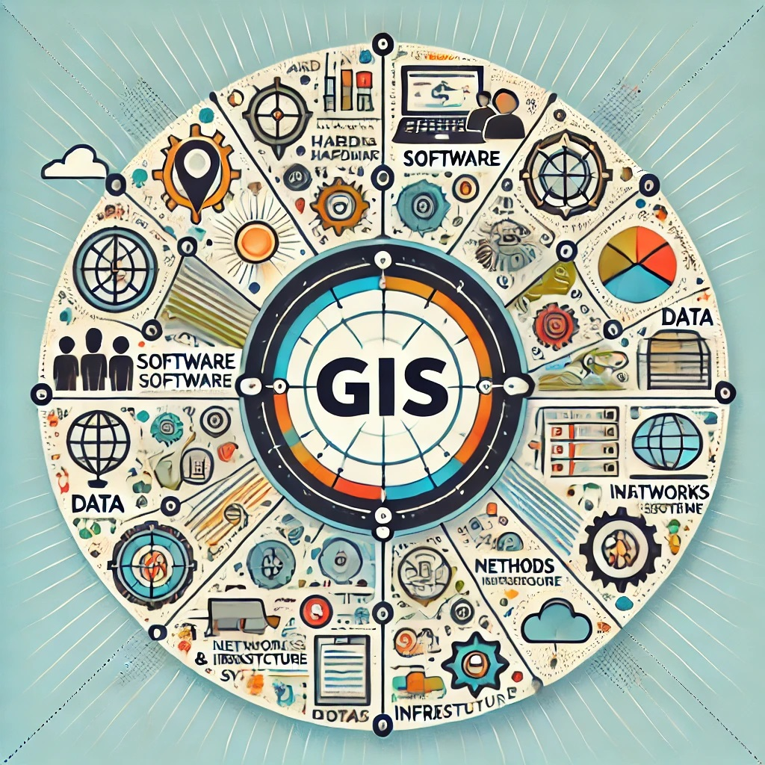

Spatial data types: vector and raster.

In GIS, spatial data is primarily categorized into two types: **vector** and **raster** data. Each has unique characteristics and is suited to different types of spatial analysis and visualization.

**1. Vector Data**

* **Description**: Vector data represents geographic features using points, lines, and polygons. Each feature is defined by its coordinates, making it precise and suitable for representing discrete objects with clear boundaries.
* **Components**:
  + **Points**: Represent discrete locations, like a city or a landmark.
  + **Lines**: Represent linear features, like roads or rivers.
  + **Polygons**: Represent areas, such as land parcels, lakes, or political boundaries.
* **Applications**: Ideal for mapping features with exact boundaries, like property lines, road networks, and administrative areas.

**2. Raster Data**

* **Description**: Raster data represents geographic information as a grid of cells or pixels, each with a value. This type is typically used for continuous data like elevation, temperature, or satellite imagery.
* **Components**:
  + **Pixels (Cells)**: Each pixel has a specific value, such as a color or a numerical value, representing the attribute at that location.
  + **Resolution**: Refers to the size of each cell, affecting the level of detail in the image. Higher resolution means more detail.
* **Applications**: Well-suited for representing continuous phenomena like rainfall, land cover, and elevation.

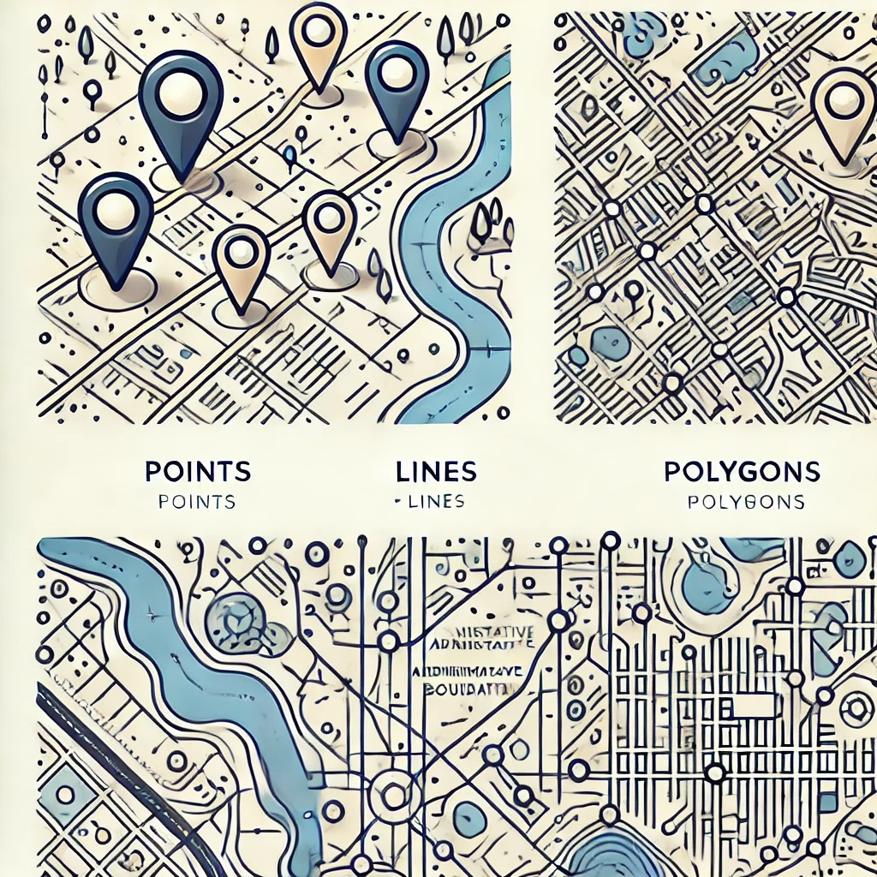

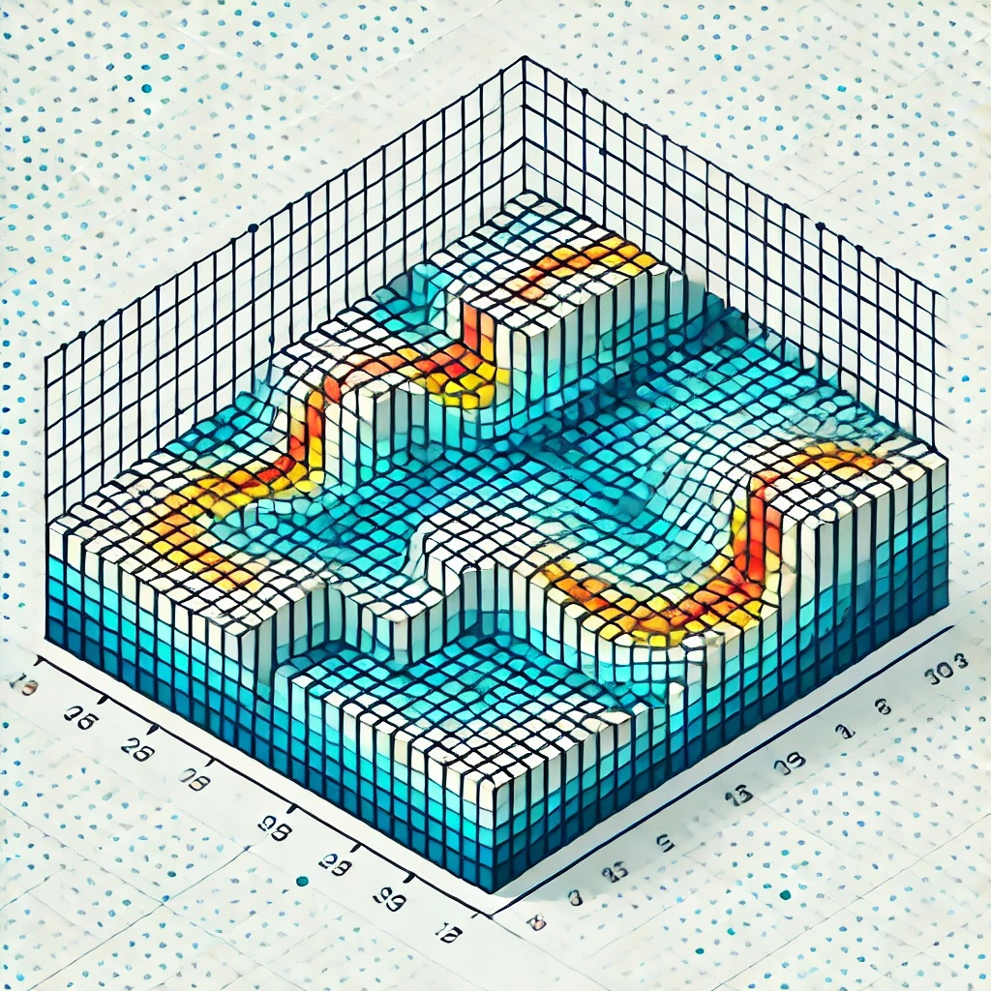

Overview of geospatial technology trends.

# **Getting started with QGIS**

## Overview of QGIS and its capabilities.

QGIS (Quantum Geographic Information System) is a free, open-source Geographic Information System (GIS) software that allows users to create, analyze, and visualize spatial data. It is widely used by GIS professionals, researchers, and organizations for mapping and spatial analysis due to its flexibility, extensive capabilities, and community support.

**Key Features and Capabilities of QGIS**

**1.** Data Management

**QGIS gives support for multiple data formats** i.e. handles raster, vector, and tabular data from various sources, including shapefiles, GeoJSON, KML, CSV, PostGIS, and more.

**Data Import and Export** such that it Facilitates seamless data exchange between QGIS and other software, enabling compatibility with industry standards.

**Database Integration**; supports spatial databases like PostgreSQL/PostGIS, SpatiaLite, Oracle Spatial, and others.

**2. Mapping and Visualization**

**Cartographic Design**; offers the capability to create professional-quality maps with custom symbology, labels, and layouts.

**Layer Styling** which allows for application of advanced styling options like heatmaps, graduated symbols, and rule-based rendering.

**3D Visualization**: Visualize spatial data in 3D to better understand elevation, terrain, and other spatial relationships.

**3. Spatial Analysis**

**Geoprocessing Tools** which are utilized to perform operations like buffering, intersecting, clipping, and union on spatial datasets.

**Raster Analysis** toolset for a variety of raster manipulation processing and analysis such as slope, aspect, reclassification, and other raster-based analyses.

**Network Analysis** solving problems related to routing, service areas, and shortest paths for utility and road networks.

**4. Plugins and Extensibility**

**Plugin Repository** which offers a wide range of plugins developed by the QGIS community for tasks like geocoding, topology checks, and advanced analysis.

**Custom Plugins**, QGIS gives the freedom to create custom plugins using Python to extend QGIS functionalities for use as you may desire and can be shared with other users.

**5. Integration with Other Software**

Seamlessly integrates with **GRASS GIS** and **SAGA GIS** for advanced spatial analysis, supports **Python scripting** with **PyQGIS** for automation and customization, and enables **web mapping** through tools like **QGIS2Web** and LizMap for sharing maps online.

**6. User-Friendly Interface**

Simplifies data handling with **drag-and-drop**, offers **customizable toolbars** for tailored workflows, and supports real-time **dynamic data visualization**.

**7. Project Sharing and Collaboration**

Easily share project files (.qgz or .qgs) with others and ensure accurate spatial representation with extensive coordinate system support.

**8. Community Support and Documentation**

Backed by an active global community offering updates and support, with extensive documentation, tutorials, and forums for all skill levels.

**Benefits of QGIS**

* **Cost-Efficiency**: Open-source and free to use for individuals, businesses, and governments.
* **Cross-Platform Compatibility**: Runs on Windows, macOS, Linux, and other platforms.
* **Scalability**: Suitable for simple mapping projects as well as complex spatial analyses.
* **Customizability**: Flexible enough to meet specific project requirements through plugins and scripting.

## Installing and configuring QGIS.

Installing and configuring QGIS involves downloading the software, installing it on your system, and setting up the environment for optimal use. Follow these steps to get started with QGIS:

**1. Downloading QGIS**

Download QGIS from the official website (<https://qgis.org>), choosing between the stable Long-Term Release (LTR) for production use or the Latest Release for new features. Select the installer for your operating system (Windows, macOS, or Linux).

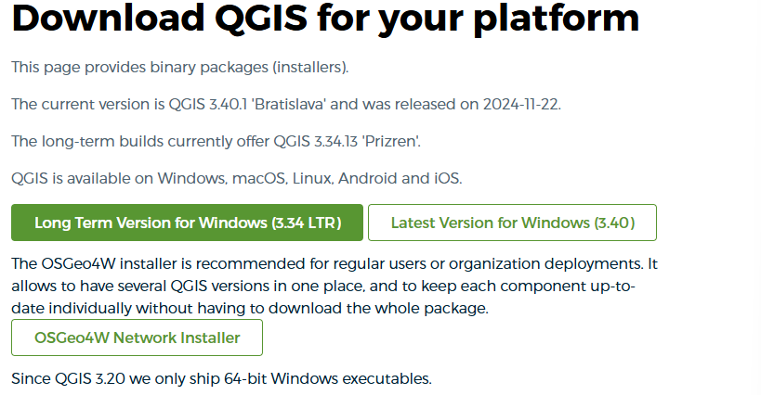

**2. Installing QGIS**

**For Windows**

1. After download the QGIS installer (.exe file) from the official website.
2. Run the installer and follow the prompts:

* Select the installation type (default recommended).
* Choose a destination folder.
* Optionally include GRASS GIS and SAGA GIS for advanced analysis.

1. Finish the installation and run QGIS.

**3. Initial Configuration**

**Launch QGIS**

* Open QGIS from your applications or start menu.
* Choose the default or custom project template (if applicable).

**Set Up the Interface**

* **Panels and Toolbars**: Customize the interface by enabling or disabling panels and toolbars from the **"View"** menu.
* **Themes**: Select a light or dark theme under ***Settings > Options > General > UI Theme***.

**Configure Plugins**

* Go to ***Plugins > Manage and Install Plugins***.
* Search for and install essential plugins like:

**QGIS2Web**: For web mapping.

**OpenLayers Plugin**: To access basemaps.

**QuickOSM**: For OpenStreetMap data.

**Processing Tools**: GRASS GIS and SAGA GIS integration.

**Set Up Coordinate Systems**

* Go to ***Settings > Options > CRS***.
* Set the default Coordinate Reference System (CRS) for new projects (e.g., **WGS 84** or a local CRS).
* Enable on-the-fly CRS transformation for seamless data integration.

## Understanding the QGIS interface (toolbars, menus, panels).

The QGIS interface is user-friendly and customizable, designed to provide access to a wide range of tools for mapping and spatial analysis. Here’s an overview of its key components:

**Main Components of the Interface**

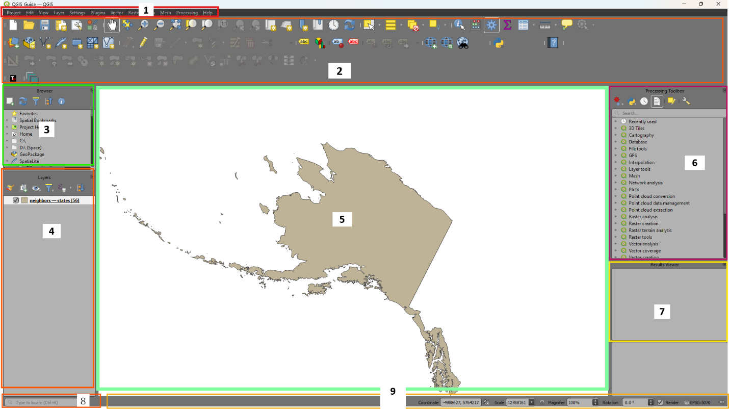

**1. Menu Bar**

Located at the top of the interface.

Provides access to all QGIS functions organized under different menus (e.g.File, Edit, View, Layer, Settings, Plugins, Help).

Key menus include:

* **Project**: Manage projects (create, open, save).
* **Layer**: Add, remove, or manage vector and raster layers.
* **View**: Adjust visibility of toolbars, panels, and the map canvas.
* **Processing**: Access advanced geospatial analysis tools.

**2. Toolbars**

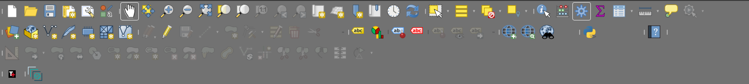

Below the menu bar, toolbars provide quick access to frequently used tools.

Common toolbars:

* + **Project Toolbar**: Create, open, save, and manage projects.
  + **Navigation Toolbar**: Zoom in/out, pan, or navigate through the map.
  + **Layer Toolbar**: Add vector, raster, and database layers.
  + **Advanced Digitizing Toolbar**: Edit and manipulate vector features.
  + **Attributes Toolbar**: Edit and query attribute data.
  + **Plugins Toolbar**: Manage and access installed plugins.

Toolbars are customizable: Right-click in the toolbar area to add or remove toolbars.

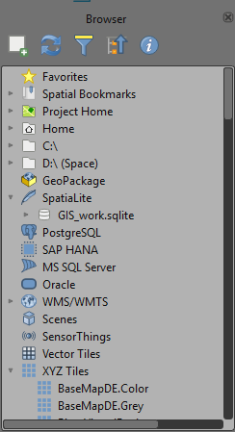**3. Browser Panel**

The Browser Panel provides quick access to data sources, allowing you to:

* Navigate files and directories for shapefiles, rasters, and other datasets.
* Connect to external data sources like databases (PostGIS, SpatiaLite), web services (WMS, WFS), or GeoPackages.
* Drag and drop data directly into the Map Canvas or Layers Panel.

This section streamlines data loading and organization for your projects.

**4. Layers Panel**

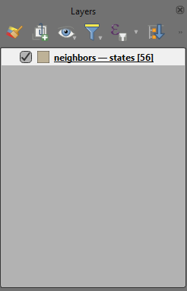

The Layers Panel lists all the data layers added to your project, allowing you to:

* Organize layers by adjusting their order (drag to rearrange).
* Control visibility by toggling the checkbox next to each layer.
* Access layer options by right-clicking (e.g., Properties, Zoom to Layer, Remove).
* Group layers for better management.

It’s essential for managing and customizing the data displayed in your Map Canvas.

**5. Map Canvas**

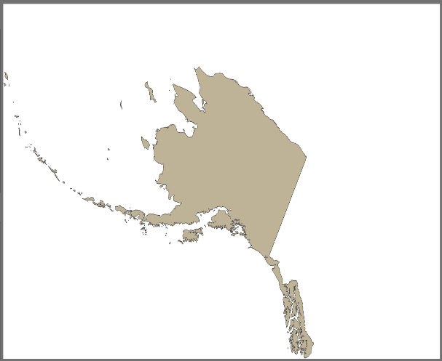

The Map Canvas is the central area where your spatial data is displayed and visualized. It allows you to:

* Interact with layers through zooming, panning, and selection tools.
* View your data as styled in the Layers Panel.
* Analyze and edit spatial data directly.

This is the primary workspace for exploring and managing your GIS data.

**6. Processing Toolbox**

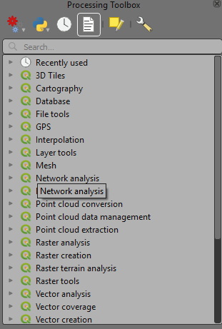

The Processing Toolbox provides access to a wide range of geoprocessing tools for spatial analysis. Key features include:

* **Tool Categories**: Organized by function (e.g., Vector, Raster, Database, GRASS GIS, SAGA GIS).
* **Search Bar**: Quickly find tools by name or keyword.
* **Batch Processing**: Run tools on multiple datasets simultaneously.
* **Custom Scripts**: Add and execute Python scripts for advanced workflows.

It’s a powerful resource for performing advanced geospatial analyses efficiently.

**7. Results Viewer**

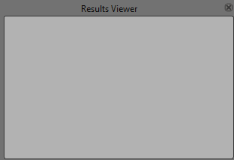

The Results Viewer displays outputs and logs from processing tasks. It allows you to:

* Review the success or errors of geoprocessing operations.
* Access detailed information about the execution process, including warnings or progress reports.
* Save or export results for documentation or further analysis.

This tool is essential for monitoring and troubleshooting geospatial workflows.



1. **Locator**

The Locator is a quick search tool, typically located at the bottom left of the interface. It allows you to:

* Search for layers, tools, or features within your project.
* Access QGIS functions directly by typing keywords.
* Quickly navigate to specific locations using coordinates.

1. **Status Bar**  
   The Status Bar is found at the bottom of the interface and provides important project details, including:

* **Scale**: Displays the current map scale.
* **Coordinate Position**: Shows the cursor’s coordinates on the map.
* **Active CRS**: Indicates the current Coordinate Reference System (CRS) in use.
* **Progress Bar**: Tracks the status of processing tasks.

These components enhance navigation and provide critical project information.

**Tips for Beginners**

* **Familiarize with Toolbars,** Start with navigation and layer management toolbars.
* **Experiment with Panels**, layers and Browser panels are critical for managing data.
* **Customize the Layout**, tailor the interface to your needs for a more efficient workflow.

## Managing projects, layers, and symbology.

QGIS provides powerful tools for managing GIS projects, organizing layers, and customizing symbology to create meaningful and visually appealing maps.

**1. Managing Projects**

Projects in QGIS are containers for spatial data, map layouts, and settings. The project file saves the arrangement of layers, symbology, and other configurations.

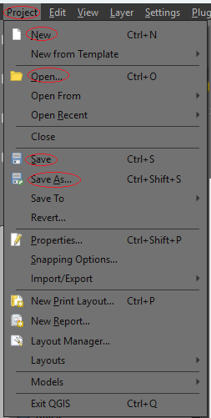**Creating and Saving a Project**

* **To create a New Project**: Navigate to ***Project > New*** or click the **New Project** icon  on the toolbar to start a new project.
* **Save Project**: Save your current project as a .qgz file by selecting ***Project > Save***  or ***Project > Save As ***
  + Note: **.qgz** files store all project data, including symbology and settings.
* **Open Existing Project**: To access a previously saved project, go to ***Project > Open.***

**Project Settings**

* **Coordinate Reference System (CRS)** , define the project’s CRS by navigating to ***Project > Properties > CRS***. Ensure the CRS aligns with your data; for global datasets, it’s recommended to use **WGS 84** for accuracy and consistency.
* **Project Environment**: Customize your workspace by setting default layer styles, rendering settings, and snapping options in ***Project > Properties***. These configurations help streamline workflows and maintain uniformity across your project.

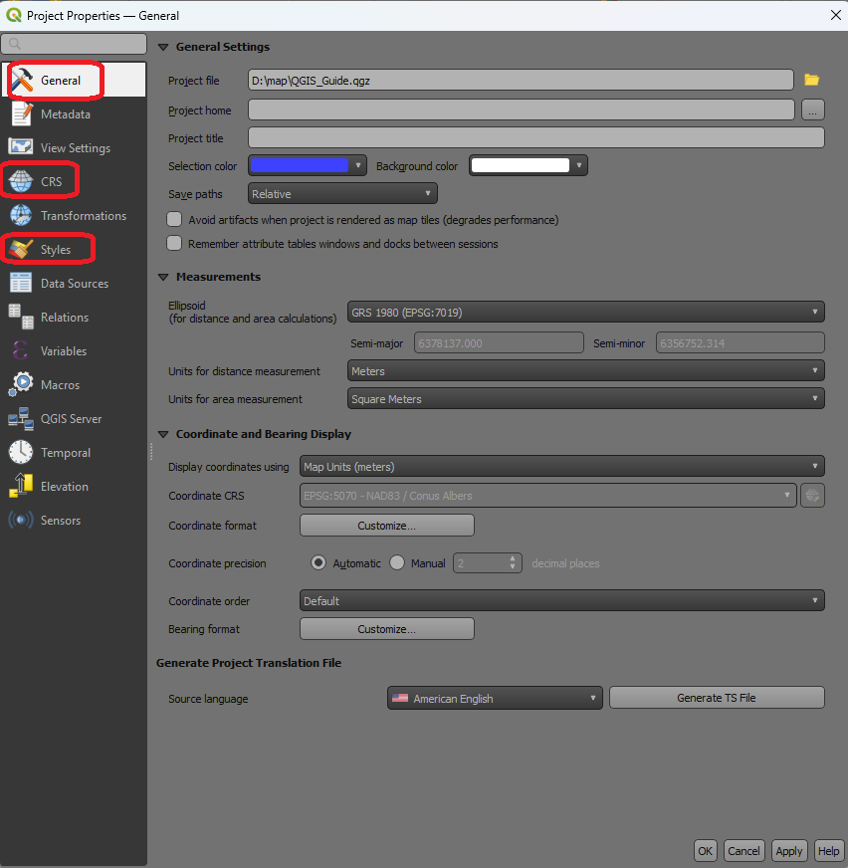

**Organizing Projects**

* Use logical file structures for data and project files.
* Store related datasets in a single directory for easier management.

**2. Managing Layers**

Layers are the building blocks of your GIS project, representing spatial data as either **vector** (points, lines, polygons) or **raster** (gridded data such as images or elevation). Effective layer management ensures a clean and organized workspace for analysis and visualization.

**Organizing Layers**

* **Reordering**:- Adjust the stacking order of layers in the **Layers Panel** by dragging them. Layers higher in the list are displayed above those lower down.
* **Grouping**:- Right-click in the Layers Panel and select **Add Group** to create folders for better organization of related layers.
* **Renaming Layers**:- Make layer names clearer by right-clicking a layer and selecting **Rename**.

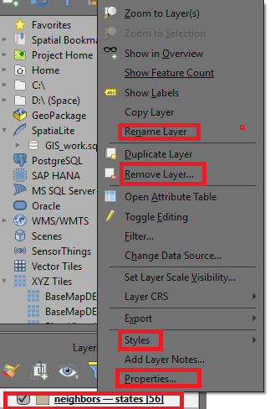

**Layer Properties**

Access layer settings by right-clicking the layer and selecting **Properties**. Key options include:

* **Information**:- View basic metadata about the layer.
* **Symbology**:- Change how the layer is styled to improve visualization.
* **Source**:- Review details about the data source, such as file paths or database connections.
* **Fields**:- Manage attribute fields to refine the data structure.
* **Joins**:- Integrate additional tables for enriched analysis.

Efficient layer organization and customization make projects easier to manage and enhance the quality of your analyses.

**3. Symbology (Layer Styling)**

Symbology determines how spatial features are visually represented on the map. QGIS provides a wide range of styling options to enhance visualization and communicate data effectively.

**Accessing Symbology Settings**

* **Via Layer Properties**: Right-click the layer, select **Properties**, then go to the **Symbology** tab.
* **Layer Styling Panel**: Use this panel for real-time style updates and previews .

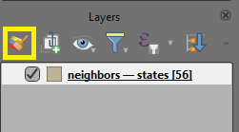

**Vector Layer Symbology**

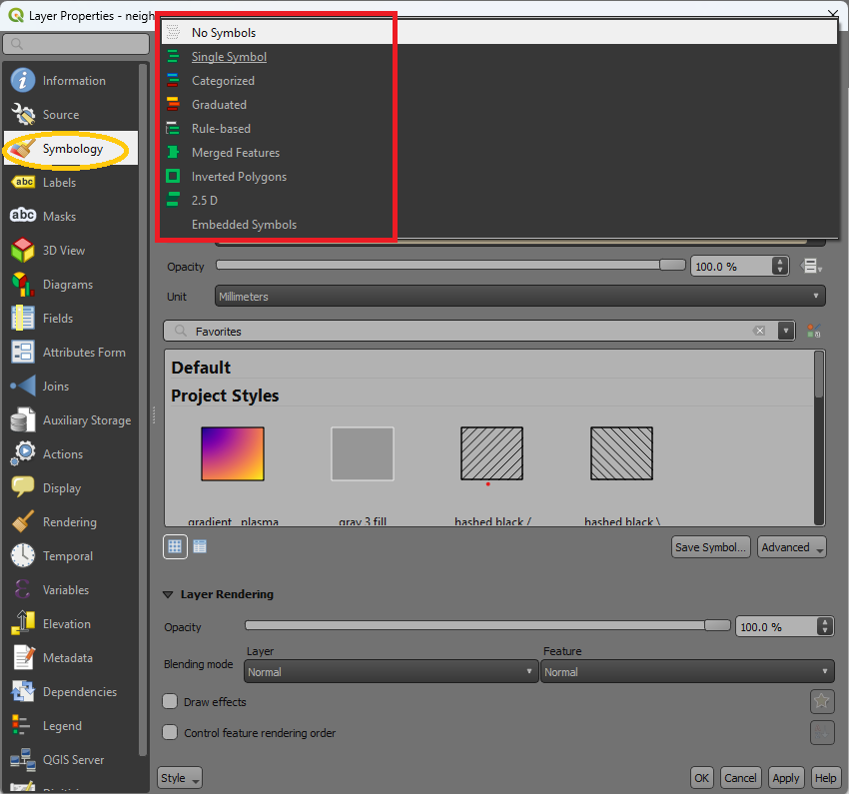

* **Single Symbol**: Apply a uniform style to all features (e.g., single color or marker).
* **Categorized**: Style features based on attribute values (e.g., different colors for land use types).
  + Select an attribute, pick a color ramp, and click **Classify**.
* **Graduated**: Represent features using numerical ranges (e.g., population density).
  + Choose an attribute, set intervals, and select a color ramp.
* **Rule-Based**: Create complex styles based on logical expressions (e.g., display roads with speed limits >50 km/h in red).

**Raster Layer Symbology**

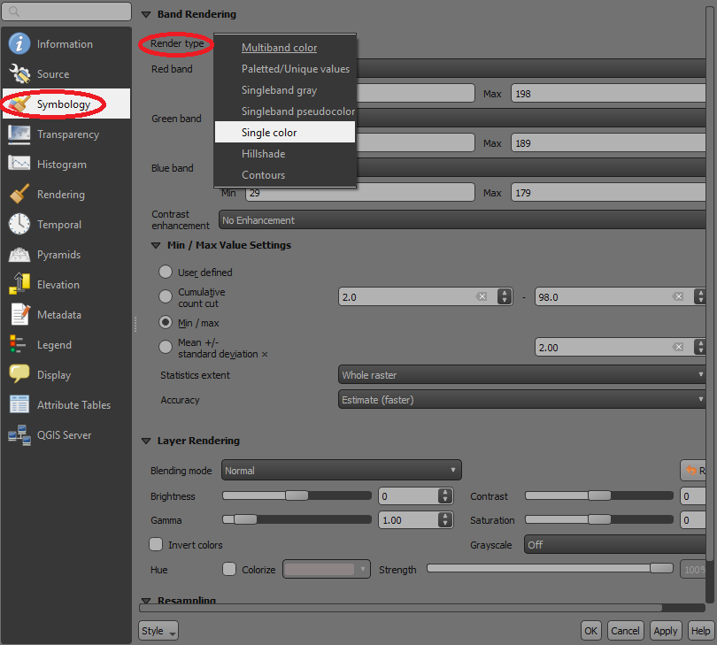

* **Singleband Gray**: Use this to visualize raster data in grayscale i.e black and white
* **Singleband Pseudocolor**: Use color ramps to represent continuous data (e.g., elevation).
* **Hillshade**: Highlight terrain features with shaded relief effects.
* Customize raster symbology through ***Properties > Symbology*** to adjust transparency, color ramps, and classifications.

**Customizing Symbols**

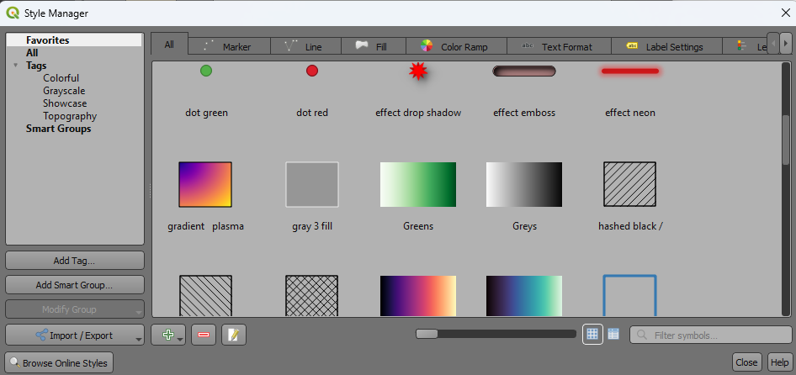

* Modify symbol size, color, shape, and outlines using the **Symbol Selector**.
* Save and load symbol styles to maintain a consistent appearance across projects.

### **Enabling and Setting Label Properties**

1. **Enable Labels**:
   * Right-click on the desired layer in the **Layers Panel** and select Show Labels or proceed and click on **Properties**.
   * Navigate to the **Labels** tab in the Layer Properties dialog.
   * From the drop-down menu, choose **Single Labels** to enable labeling for all features in the layer.

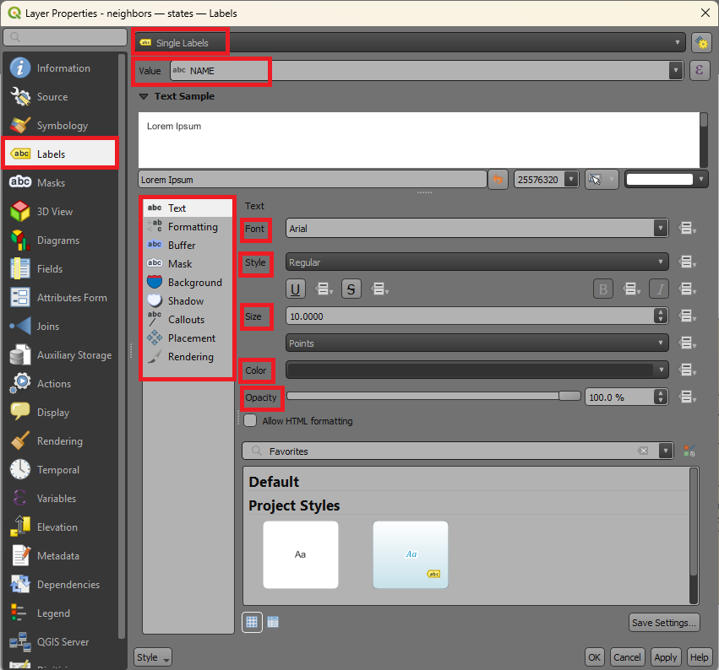

1. **Select an Attribute Field**:
   * Under the **Label with** option, select the attribute field you want to use as the label text (e.g., a name or ID field).
2. **Customize Font and Appearance**:
   * Adjust the font type, size, style (bold, italic), and color under the **Text** settings do this by changing to different settings.
   * In other settings below add additional effects like halos, shadows, or outlines to enhance label visibility.
3. **Set Label Placement**:
   * Configure label positioning under the **Placement** settings:
     + For points, choose from options like above, below, or offset.
     + For lines, align the label to follow the curve of the line.
     + For polygons, position the label inside or near the feature.
4. **Apply and Save Settings**:
   * After customizing the label properties, click **Apply** to see the changes in the Map Canvas.
   * Click **OK** to save the settings and close the dialog.

* **Tips for Effective Management**
* **Use Meaningful Layer Names**: Rename layers descriptively to make projects easier to understand.
* **Group Layers**: Organize layers into logical groups for large projects.
* **Symbology Templates**: Save commonly used styles as templates to reuse in other projects.
* **Backup Projects**: Save copies of project files and data in case of accidental changes or loss.

# **Working with spatial data**

## Importing and exporting geospatial data (Shapefiles, GeoJSON, CSV).

QGIS supports various geospatial data formats, including Shapefiles, GeoJSON, and CSV. Here’s a guide to importing and exporting these formats.

1. **Importing Spatial Data**

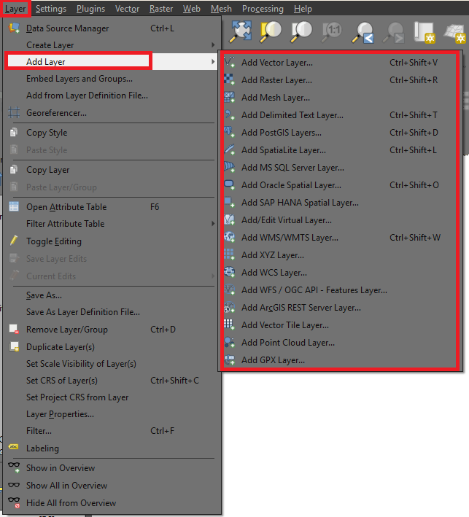

**Shapefiles and GeoJSON**

**Using the Menu Bar**:

* + Navigate to ***Layer > Add Layer > Add Vector Layer***.
  + Click **Browse** and locate the desired file (Shapefile or GeoJSON).

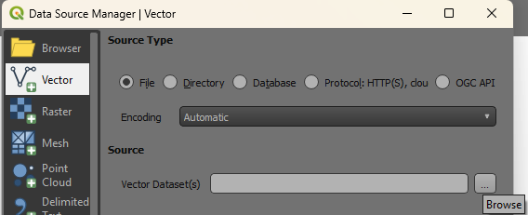

* + Select the file and click **Open**.
  + The layer will appear in the **Layers Panel** and the **Map Canvas**.
* **Drag-and-Drop**: Simply drag the file directly into the QGIS interface from your file browser.

**CSV (Comma-Separated Values)**

**Using the Menu Bar**:

* + Navigate to **Layer > Add Layer > Add Delimited Text Layer**.
  + Browse and select the .csv file.
  + Configure the settings:
    - **X Field**: Select the column containing longitude.
    - **Y Field**: Select the column containing latitude.
    - **Coordinate Reference System (CRS)**: Choose an appropriate CRS (e.g., WGS 84 - EPSG:4326 for geographic coordinates).
  + Click **Add** to load the CSV as a spatial layer.

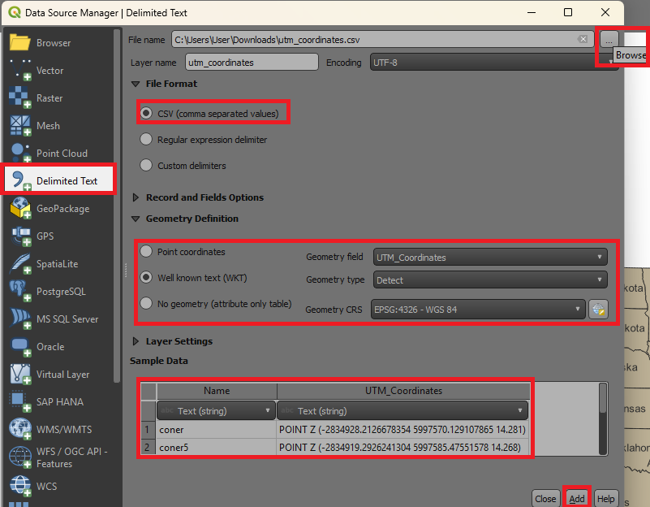

* **Drag-and-Drop**: Alternatively drag the CSV file directly into the QGIS interface, and a dialog box will prompt you to configure its spatial settings.

1. **Exporting Spatial Data**

QGIS allows you to export spatial data into various formats with a consistent workflow. Follow these steps to export your layers effectively:

1. **Select the Layer**:
   * Right-click the layer in the **Layers Panel**.
2. **Choose Export Option**:
   * Select ***Export > Save Features As*** from the context menu.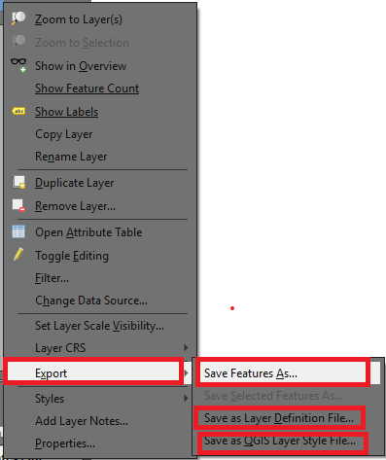

1. **Configure Export Settings**:
   * **Format**: Choose the desired output format (e.g., Shapefile, GeoJSON, KML).
   * **File Name**: Click **Browse** to specify the save location and file name.
   * **CRS (Coordinate Reference System)**: Ensure the CRS matches your requirements or select a new CRS for the exported file.
   * **Extent**: Optionally, limit the export to a specific geographic extent.
2. **Customize Attributes** (Optional):
   * Use the **Layer Options** section to include or exclude specific attributes in the output.

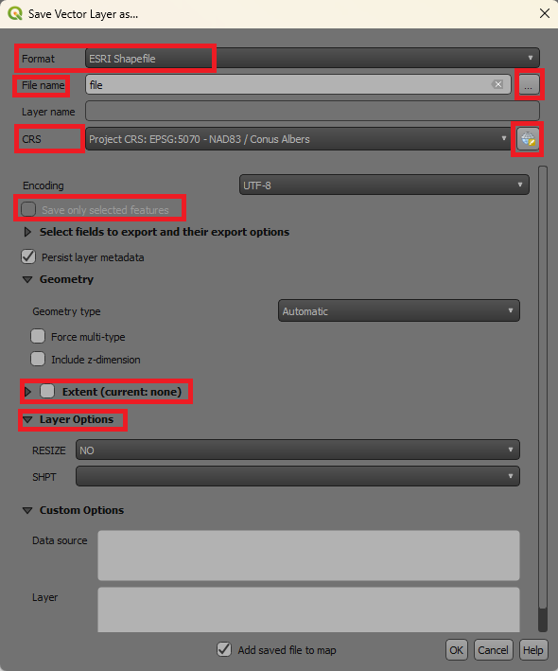

1. **Save**:
   * Click **OK** to export the layer to the chosen format and location.

## Coordinate systems and projections.

In GIS, understanding coordinate systems and projections is critical for accurately representing spatial data on the Earth's surface. Here's an overview of the concepts and their significance;

### What are Coordinate Systems

A coordinate system is a reference framework that uses coordinates to define the locations of features on a two- or three-dimensional surface.

### Types of Coordinate Systems

1. **Geographic Coordinate System (GCS)**:
   * Represents locations on a spherical surface (Earth).
   * Uses latitude and longitude measured in degrees.
   * Example: WGS 84 (World Geodetic System 1984).
   * Common Uses: Global datasets, navigation, and mapping.
2. **Projected Coordinate System (PCS)**:
   * Projects the Earth's curved surface onto a flat plane.
   * Units are typically in meters or feet.
   * Example: UTM (Universal Transverse Mercator), State Plane.
   * Common Uses: Local and regional mapping for accurate distance and area measurements.

### What are Projections

A projection is a mathematical transformation that converts the Earth's curved surface (3D) into a flat, 2D map. Each projection introduces some distortion in shape, area, distance, or direction.

### Types of Projections

1. **Conformal Projections**:
   * Preserve shape.
   * Example: Mercator projection.
   * Common Uses: Navigation.
2. **Equal-Area Projections**:
   * Preserve area.
   * Example: Albers Equal-Area, Mollweide.
   * Common Uses: Thematic mapping (e.g., population density).
3. **Equidistant Projections**:
   * Preserve distances along certain lines.
   * Example: Equidistant Cylindrical.
   * Common Uses: Measuring distances from a central point.
4. **Azimuthal Projections**:
   * Preserve direction from a central point.
   * Example: Lambert Azimuthal Equal-Area.
   * Common Uses: Polar maps, aviation.

### Factors to consider while choosing a Projection

The choice of projection depends on:

* **Purpose**: Navigation, thematic mapping, distance measurement.
* **Region of Interest**:
  + Large-scale maps (local): Use UTM or State Plane.
  + Small-scale maps (global): Use Robinson or Winkel Tripel.
* **Feature Importance**: Minimize distortion in the most critical aspect (shape, area, or distance).

### Coordinate Reference Systems (CRS)

A CRS defines how spatial data is projected and tied to locations on the Earth.

**Components of CRS:**

* **Datum**:
  + A model of the Earth used for measuring positions.
  + Example: WGS 84 (global), NAD 83 (North America).
* **Projection**:
  + Defines how the Earth’s surface is flattened for mapping.
* **Units**:
  + Specifies the measurement units (e.g., meters, feet, degrees).

### Common CRS Examples

* **WGS 84 (EPSG:4326)**:
  + A global geographic coordinate system.
  + Units: Degrees.
  + Common for GPS and global datasets.
* **UTM (Universal Transverse Mercator)**:
  + A projected system dividing the world into zones.
  + Units: Meters.
  + Common for regional mapping.

### Working with CRS in QGIS

**Setting the CRS**:

* + Go to ***Project > Properties > CRS*** to set the project CRS.
  + Recommended CRS for global data: **WGS 84**.
  + For local data, choose a CRS suitable for the region.

**Reprojecting Layers**:

* + Right-click a layer in the ***Layers Panel > Export > Save Features As***.
  + Select the desired CRS for reprojection.
  + Alternatively search for the reproject tool in the processing toolbox, select layer(s) to transform and set destination CRS, in this option you can be able to see if the target CRS covers your area of interest.

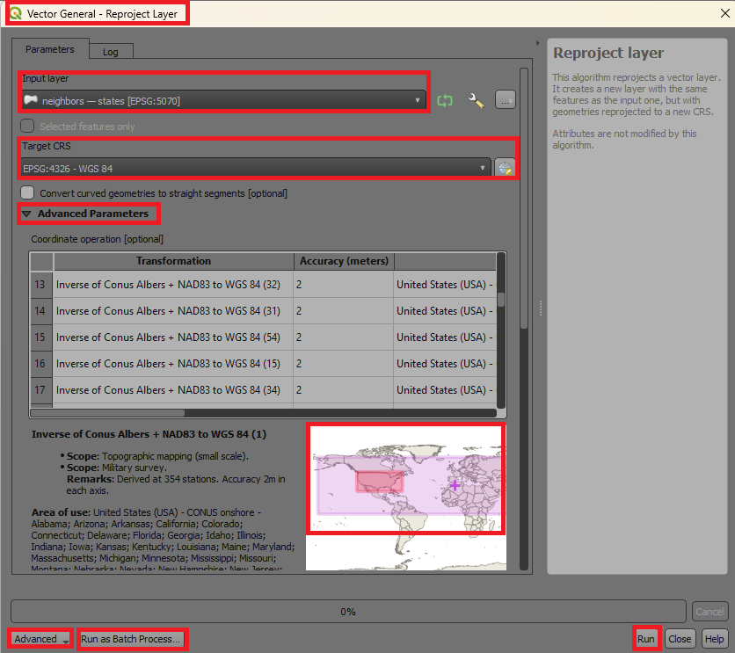

**On-the-Fly CRS Transformation**:

* + Enable this in QGIS ***(Settings > Options > CRS)*** to align layers with different CRS.

**Checking CRS**:

* + Right-click a ***layer > Properties > Source*** to view or modify its CRS.

### Practical Considerations

* Always verify the CRS of your data before analysis.
* Align the CRS of all layers in a project to avoid misaligned maps.
* Use metadata to track the original CRS of datasets.

### Common Challenges

* **CRS Mismatch**: Layers appear misaligned due to different CRS settings.
  + Solution: Reproject layers or enable on-the-fly CRS transformation.
* **Datum Shifts**: Small positional differences due to different datums.
  + Solution: Use consistent datums across datasets.

## Basic data management (attribute tables, editing features).

Efficient data management is a critical skill in GIS. This involves working with **attribute tables** (which store descriptive information about spatial data) and **editing features** (modifying spatial and non-spatial data). Here’s how to manage these elements in QGIS.

**1. Attribute Tables**

The **attribute table** is a tabular representation of non-spatial data associated with each feature in a spatial layer.

**Opening an Attribute Table**

* Right-click the layer in the ***Layers Panel > Open Attribute Table*** 
* Alternatively, select the layer and click the **Open Attribute Table** icon in the toolbar, by default you can use **F6** as a shortcut to open the attribute table.

**Structure of the Attribute Table**

* **Rows**: Represent individual features (points, lines, polygons).
* **Columns (Fields)**: Contain attribute information (e.g., name, area, population).
* **Feature IDs**: Unique identifiers for each feature.

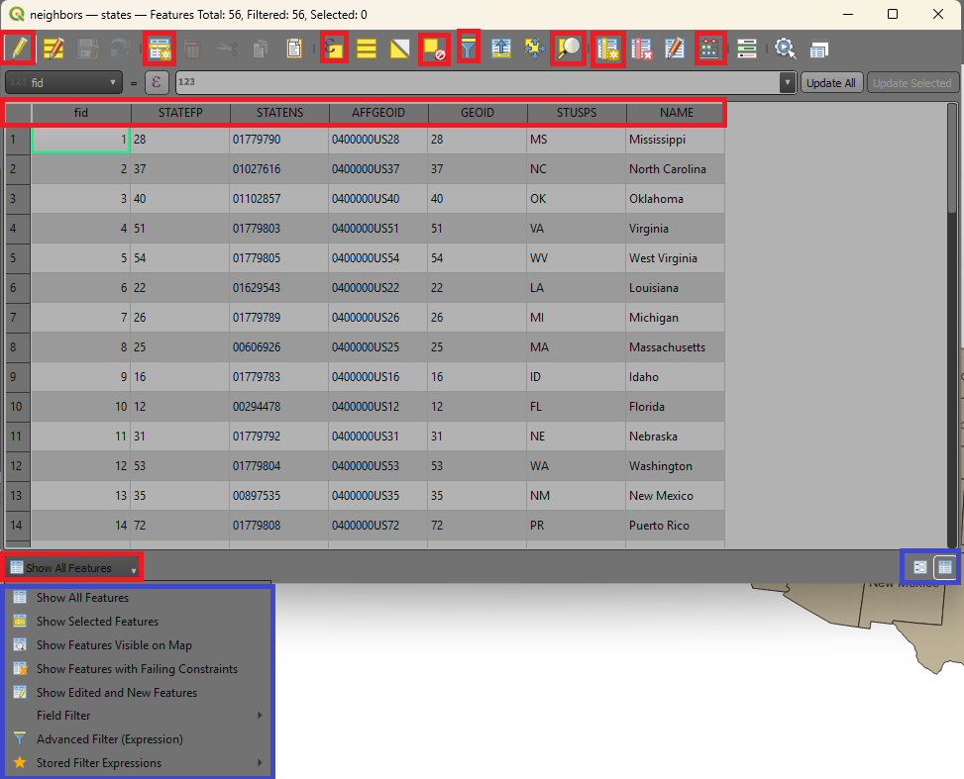

**Managing Attributes**

* **Sorting**: Click a column header to sort features by that attribute.
* **Filtering**:
  + Use the **Filter ** option in the attribute table to display and select specific features.

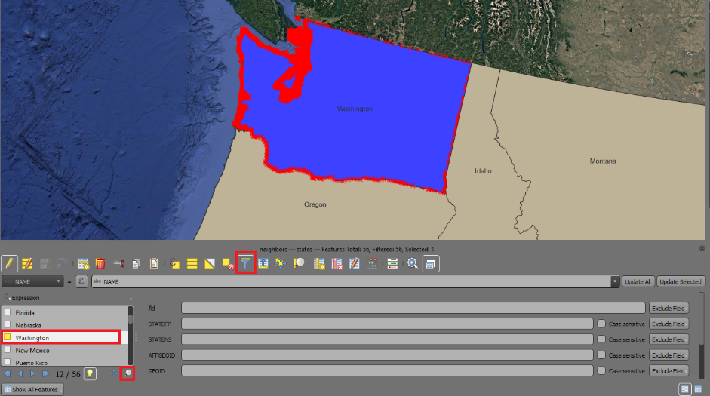

* **Field Calculator**:
  + Use the Field Calculator (Open Field Calculator icon)  to compute new attribute values.

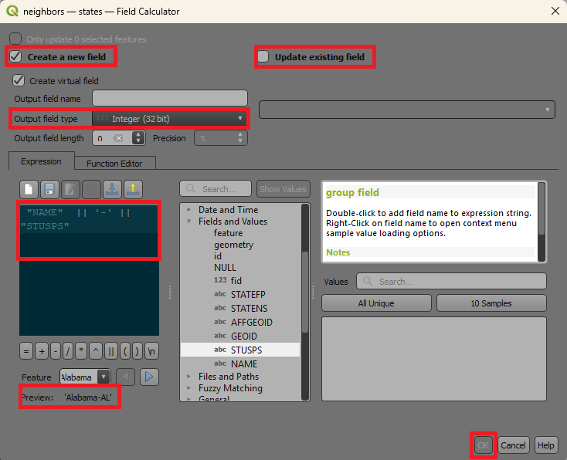

**Editing Attributes**

* Enable editing mode: Click the **Toggle Editing ** button in the attribute table.
* Modify values directly in the table by changes them to what you want.
* Save edits by clicking the **Save Layer Edits** button. 

**2. Editing Features**

Editing features involves modifying the geometry (shape) or attributes of spatial data.

1. **Enabling Editing Mode**

* Right-click the layer in the ***Layers Panel > Toggle Editing***. 
* Once enabled, tools for adding, deleting, and modifying features become available.

1. **Editing Tools**

* **Adding Features**:
  + Select the **Add Feature** tool  from the toolbar.
  + Click on the map to draw the geometry (e.g., a point, line, or polygon).
  + Enter attribute data in the pop-up dialog.
* **Modifying Features**:
  + **Move Features**: Use the **Move Feature** tool  to reposition features this comes in handy when a feature is misplaced.
  + **Vertex Editing**:
    - Select the **Vertex Tool** to move, add, or delete vertices in lines or polygons.
    - Useful for refining boundaries or shapes.
* **Deleting Features**:
  + Select the **Delete Selected Feature(s)** tool. 
  + Click on the feature or select multiple features and press **Delete**.
* **Splitting and Merging Features**:
  + **Split Features**: Use the **Split Features** tool  to divide a polygon or line into multiple parts.
  + **Merge Features**: Select multiple features > ***Right-click > Merge Selected*** Features. 
* **Snapping Options**:
  + Enable snapping under Settings > Snapping Options.
  + Helps ensure new features align with existing ones (e.g., road intersections).

**3. Adding and Managing Fields**

**Adding New Fields:**

1. Open the attribute table and enable editing mode.
2. Click the **New Field** button 
3. Specify:

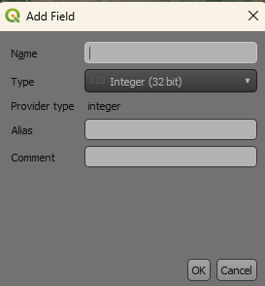

* Field name.
* Data type (e.g., integer, text, decimal).
* Length and precision (for numeric fields).

1. Click OK to add the field.

**Deleting Fields:**

1. Enable editing mode.
2. Select the field(s).
3. Click the **Delete Field** button.

* **Tips for Effective Data Management**

**Backup Data**:

* + Always create backups before editing to avoid data loss.

**Use Editing Mode Carefully**:

* + Only enable editing mode when necessary.
  + Save edits frequently to avoid losing changes.

**Validate Data**:

* + Use the **Topology Checker** plugin to identify geometry errors like overlaps or gaps.

**Maintain Attribute Consistency**:

* + Standardize attribute data formats (e.g., consistent naming conventions).

## Layer symbology

Layer symbology in QGIS allows you to visually represent spatial data in meaningful ways. Depending on the type of analysis or visualization you need, QGIS provides several symbology options: **Single Symbol**, **Categorized**, **Graduated**, **Rule-Based**, and **Clusters**. Here’s an overview of each;

**1. Single Symbol**

Description, all features in the layer are represented using the same symbol.

Use cases include but are not limited to general-purpose maps where individual feature distinctions are unnecessary and background layers or outlines for context.

**How to Apply**

* + Right-click the layer in the ***Layers Panel > Properties > Symbology***.
  + Select Single Symbol in the dropdown menu. 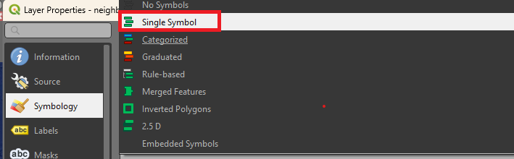
  + Customize symbol properties (e.g., color, size, outline) using the **Symbol Selector**.

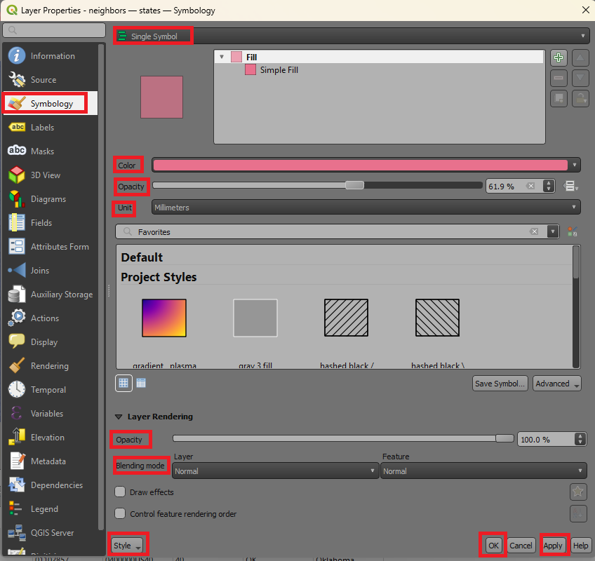

**2. Categorized**

Features are styled based on unique values in a selected attribute field.

Used to represent categorical data such as land use types, administrative boundaries, or road classifications.

**How to Apply**:

1. Right-click **the *layer > Properties > Symbology***.
2. Select Categorized.
3. Choose an attribute field (e.g., landuse or type).
4. Click Classify to generate categories.
5. Assign colors or styles to each category.

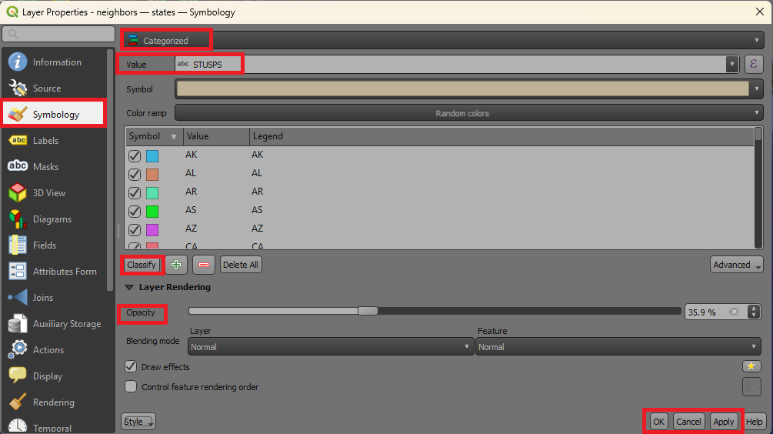

**3. Graduated**

Features are styled based on a numerical attribute field, divided into ranges or classes.

Best at representing continuous data like population density, elevation, or rainfall.

**How to Apply**:

* 1. Right-click the ***layer > Properties > Symbology***.
  2. Select Graduated 
  3. Choose a numeric attribute field (e.g., population or elevation).
  4. Select a **classification method** (e.g., Equal Interval, Natural Breaks).
  5. Choose a color ramp for the visualization.
  6. Adjust class intervals as needed.

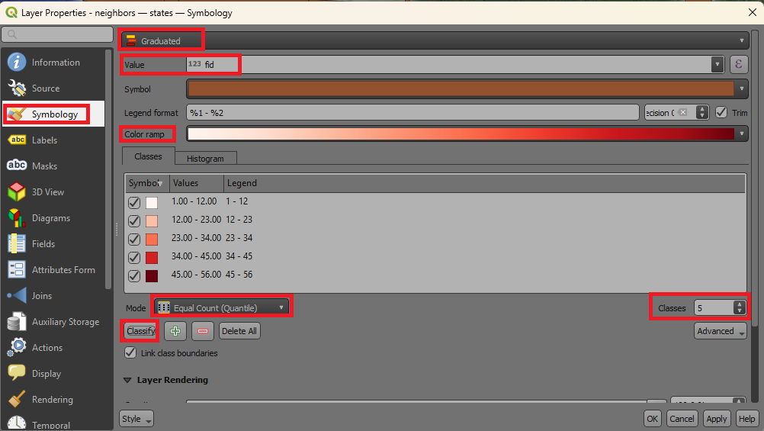

**4. Rule-Based**

This kind of symbology is utilized to apply custom rules to style features based on logical expressions.

Used in cases such as complex visualizations where multiple conditions must be represented and combining styling for attributes and geometry.

**How to Apply**:

* 1. Right-click the ***layer > Properties > Symbology***.
  2. Select Rule-Based.
  3. Click the **Add Rule** button 
  4. Define rules using expressions 
  5. Assign styles to each rule and click **Apply** then **OK** to close window.

**5. Clusters**

Groups nearby points into clusters, useful for visualizing dense datasets.

Effective for representing large point datasets like accident locations, wildlife sightings, or population distribution.

**How to Apply**:

* 1. Right-click the ***layer > Properties > Symbology.***
  2. Select Cluster.
  3. Adjust cluster settings:
     1. **Distance**: Controls the proximity required for points to cluster.
     2. **Symbol Size and Color**: Customize the cluster appearance.
  4. Apply additional scaling or labels for cluster counts.
* **Tips for Effective Symbology**
* **Use Meaningful Colors**:
  + Use intuitive color schemes (e.g., blue for water, green for forests).
  + Avoid overloading maps with too many colors.
* **Add Labels**:
  + Enable labels to improve feature identification ***(Properties > Labels).***
* **Layer Transparency**:
  + Adjust transparency to avoid obscuring underlying layers ***(Properties > Symbology > Transparency)***.
* **Save Styles**:
  + Save frequently used styles as templates for reuse in other projects ***(Right-click Layer > Styles > Save Style)***.

## Layer labelling

Labeling is an essential aspect of map design, used to identify and describe features in a spatial dataset. QGIS provides powerful tools to customize label placement, visibility, and styling.

**1. Enabling Labels**

1. Right-click the layer in *the* ***Layers Panel > Properties > Labels.***
2. Select Single Labels or Rule-Based Labels or any other
3. Choose the attribute field to use for the label (e.g., name, population) then click **Apply** then **OK**.

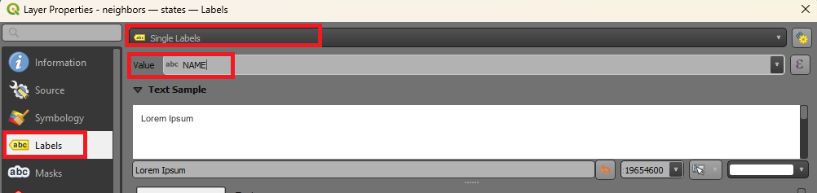

**2. Label Placement**

Label placement ensures labels do not overlap and are positioned appropriately relative to features.

**Options for Placement**

* Go to ***Properties > Labels > Placement***.
* Options vary depending on feature geometry:
  + **Points**: Place labels above, below, left, right, or at the center of points.
  + **Lines**: Align labels parallel to lines, curved along the feature, or placed at specific intervals.
  + **Polygons**: Place labels inside polygons, offset from edges, or centered.

**Custom Placement Settings**

* **Offset**: Adjust the distance of the label from the feature.
* **Anchor Points**: Define specific anchor points for the label relative to the feature.
* **Priority**: Set priorities for labels to ensure critical labels are placed first.

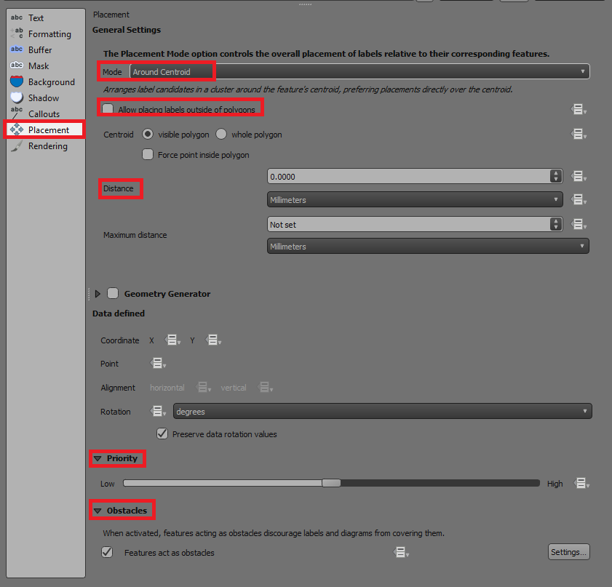

**3. Scale-Dependent Labels**

Scale-dependent labeling ensures labels appear only at appropriate zoom levels, avoiding clutter at smaller scales.

**How to Set Scale-Dependent Labels**

1. Go to ***Properties > Labels > Rendering***.
2. Check **Scale dependent visibility** 
3. Set the minimum and maximum scale values:
   * **Minimum Scale**  Labels disappear when zoomed out beyond this scale.
   * **Maximum Scale**  Labels disappear when zoomed in beyond this scale.

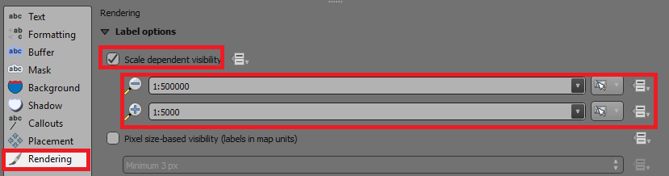

1. Apply and test the settings by zooming in and out.

**4. Masking Labels**

Masking helps labels stand out by creating a background or border that obscures underlying features or other labels.

**How to Add a Mask**

1. Go to ***Properties > Labels > Mask****.*
2. Enable **Draw Mask**.
3. Customize the mask:
   * **Mask Size**: Adjust the thickness of the mask.
   * **Transparency**: Adjust opacity for the buffer.
   * Select and set the **Pen join style**

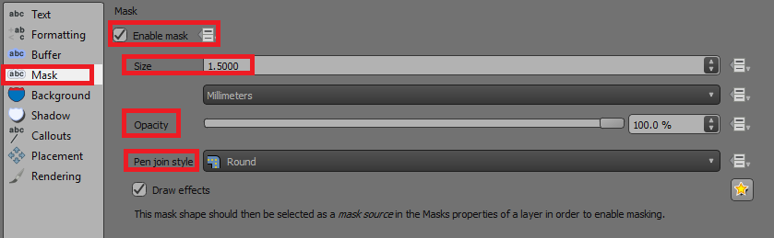

1. Apply the settings to make the labels more readable.

**5. Buffering Labels**

A buffer adds space around a label to make it more legible and visually distinct.

**How to Add a Label Buffer**

1. Go to ***Properties > Labels > Buffer****.*
2. Enable the **Buffer** option.
3. Configure buffer settings:
   * **Buffer Size**: Set the distance around the label text (measured in map units or points).
   * **Color**: Choose a background color
   * **Opacity**: Adjust transparency for subtle effects.
   * **Join Style**: Choose rounded or mitered corners for the buffer.

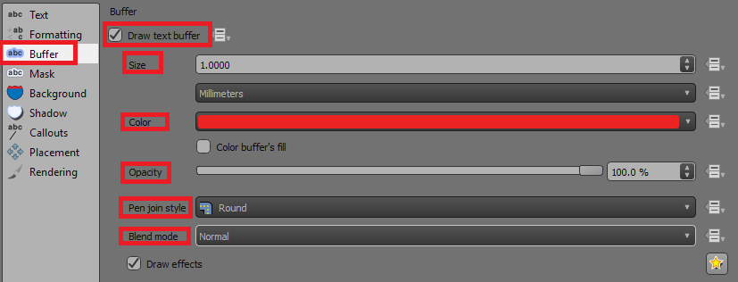

1. Preview the changes on the map.

**Practical Applications**

1. **Point Data**: Label cities with names, and place labels offset from points to avoid overlap.
2. **Line Data**: Label rivers with names aligned along the curves of the rivers.
3. **Polygon Data**: Label administrative boundaries with region names, centered within polygons.
4. **Custom Designs**:
   * Use buffers for labels over imagery to ensure readability.
   * Apply scale-dependent labeling for dense datasets like roads or buildings.

**Tips for Effective Labeling**

* **Avoid Clutter**: Use scale-dependent rendering to minimize label overlap.
* **Consistency**: Use uniform fonts and colors for similar features across layers.
* **Hierarchy**: Use size and boldness to prioritize important labels.

## Spatial data queries

Spatial data queries allow you to filter or select specific features in a dataset based on their attributes, location, or relationships with other features. Here’s an overview of the most common query methods in QGIS.

1. **Select by Expression**

This method uses expressions to query features based on attribute data or calculated values.

**Steps to Perform Select by Expression**

1. Open the layer's **Attribute Table** (Right-click the layer > Open Attribute Table) or press F6 once selected.
2. Click the **Select Features by Expression** icon  in the toolbar.
3. Build your query in the **Expression Builder**.

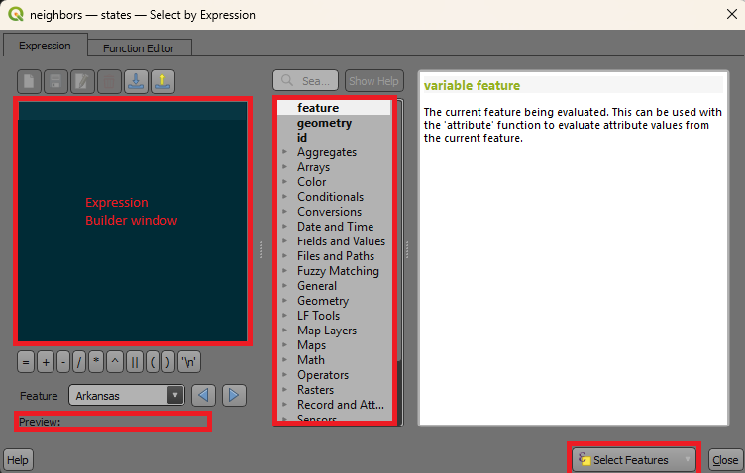

**Common Query Examples**

* **Equality and Comparison**:
  + Select features where a field equals a specific value  
    
  + Select features with values greater than a threshold  
    
* **String Matching**:
  + Select features where a field contains part of a string  
    
* **Logical Operators**:
  + Combine conditions with AND/OR  
    
* **Geometry Functions**:
  + Select features based on spatial properties  
     (select polygons larger than 5000 units)

**Tips:**

* Use the **Function List** to explore available expressions.
* Click **Test** to preview the selection.

1. **Select by Location**

This method selects features based on their spatial relationship with features in another layer.

**Steps to Perform Select by Location**

1. Go ***to Vector > Research Tools > Select by Location***.
2. Configure the query:
   * **Input Layer**: The layer whose features you want to select.
   * **Predicate**: Define the spatial relationship (e.g., Intersects, Within, Touches).
   * **Overlay Layer**: The layer used as the reference for the spatial query.

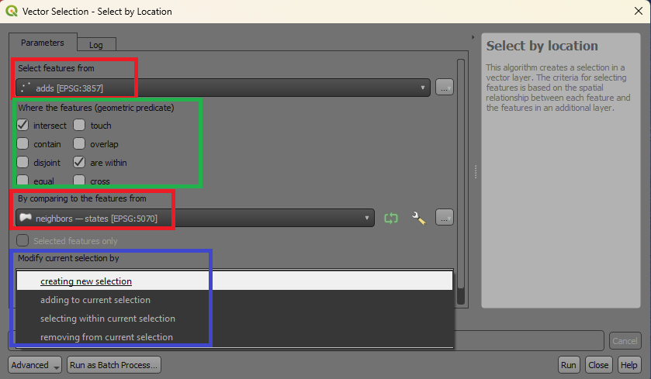

1. Click **Run** to perform the selection.

**Common Spatial Relationships**

* **Intersects**: Select features that touch or overlap the reference layer.
* **Within**: Select features entirely within the reference layer.
* **Contains**: Select features that completely contain the reference layer.
* **Touches**: Select features that share a boundary with the reference layer.

1. **Select by Value**

This method is the simplest and is used to select features based on specific attribute values.

**Steps to Perform Select by Value**

1. Open the layer's **Attribute Table** press **F6**
2. Click the **Select Features by Value** button in the toolbar.
3. Configure the query:
   * Choose the **Field** to query.
   * Select the **Operator** (e.g., Equals, Contains).
   * Enter the **Value** to match.



1. Click **OK** to select matching features.

**Combining Query Methods**

QGIS allows you to combine multiple selection methods for more complex queries:

* Use **Select by Expression** to filter by attributes.
* Apply **Select by Location** on the filtered results to further refine the selection.

**Exporting Selected Features**

* Once features are selected, you can export them as a new layer:
  1. ***Right-click the layer > Export > Save Selected Features As***.
  2. Choose a format (e.g., **Shapefile**, **GeoJSON**) and save the file.

**Tips for Effective Queries**

* **Validate Queries**: Test expressions and location queries before applying them to ensure correctness.
* **Combine Attributes and Location**: Use both attribute and spatial queries to refine results.
* **Save Selection**: Use **Vector > Research Tools > Save Selected Features** to save results for reuse.

# **Geospatial Analysis**

## Vector analysis (Geoprocessing)

1. **Buffe**r

Buffering is a key geoprocessing technique used in geospatial analysis. It creates a zone around a feature at a specified distance. This zone can represent areas of influence, proximity, or impact.

A **buffer can be said to be** a polygon or area created around a point, line, or polygon feature to represent a zone within a specified distance.

* **Point Buffer**- Creates circular areas around points (e.g., a 500m zone around schools).
* **Line Buffer**- Creates a band around linear features (e.g., a 1km buffer around roads).
* **Polygon Buffer**- Creates an expanded area around polygons (e.g., a protected zone around parks).

**Applications of Buffering**

* **Environmental Planning**: Identifying areas affected by pollution or natural disasters.
* **Urban Planning**: Defining zones around utilities or infrastructure (e.g., power lines, roads).
* **Proximity Analysis**: Determining access to services like schools, hospitals, or public transit.
* **Wildlife Conservation**: Delineating buffer zones around habitats to prevent human interference.

**Steps to Perform Buffering in QGIS**

1. **Open the Buffer Tool**:
   * Go to ***Vector > Geoprocessing Tools > Buffer****.* Alternatively, use the **Processing Toolbox** to search for the **Buffer** tool.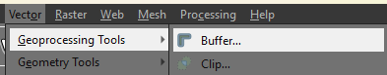
2. **Configure Buffer Parameters**:
   * **Input Layer**: Select the layer you want to buffer.
   * **Distance**: Specify the buffer distance (in the same units as the layer's CRS) such as 500 meters.
   * **Segments**: Define the number of segments to smooth curved edges. Higher values produce smoother buffers.
   * **Dissolve Option**:
     + **Enabled**: Combines overlapping buffer zones into one.
     + **Disabled**: Keeps individual buffer zones separate.

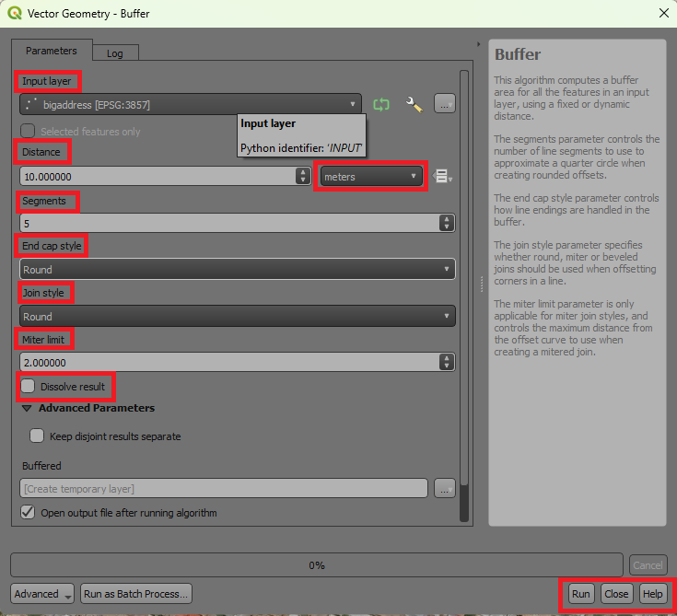

1. **Run the Tool**. Click **Run** to generate the buffer layer.
2. **Clip**

**Clipping** is a geoprocessing operation used to extract portions of a dataset that fall within the boundaries of another dataset. It is commonly used to focus on specific areas of interest by "cutting" layers to a desired boundary. In a more refined manner we could explain this as the process of trimming one layer (input layer) to the extent of another layer (clip layer). The result is a new layer that contains only the features or portions of features from the input layer that intersect the clip layer.

**Applications of Clipping**

* **Focus Area Analysis**: Extract features within a specific region (e.g., cities within a state boundary).
* **Environmental Studies**: Isolate data within ecological zones or watersheds.
* **Map Production**: Reduce the size of large datasets to fit specific areas of interest.

**How to Perform Clipping in QGIS**

1. **Open the Clip Tool**. Go to **Vector > Geoprocessing Tools > Clip**. Alternatively, use the **Processing Toolbox** Clip tool.
2. **Configure Clip Parameters**:
   * **Input Layer**: Select the layer you want to clip (e.g., land cover data).
   * **Clip Layer**: Select the boundary layer used to "clip" the input layer (e.g., administrative boundaries).
   * **Output Layer**: Specify a name and location for the clipped layer (if not saving as temporary).

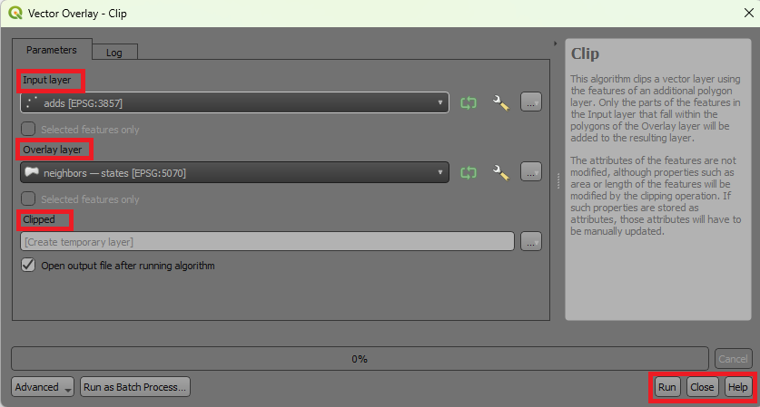

1. **Run the Tool**. Click **Run** to execute the clip operation.
2. **Dissolve**

**Dissolve** is a geoprocessing operation used to **merge** adjacent features in a vector layer based on a common attribute or without any attribute distinction. It simplifies datasets by combining features and removing internal boundaries. This tool combines features in a vector layer into a single feature or multiple grouped features by aggregating their geometries and attributes. It eliminates unnecessary boundaries within or between features.

**Applications of Dissolve**

* **Simplify Data**: Combine multiple administrative boundaries (e.g., states into a country).
* **Group Features**: Aggregate regions with a common attribute (e.g., same land use type).
* **Area Calculations**: Create contiguous zones for accurate area measurement.
* **Preprocessing for Analysis**: Simplify datasets before further geospatial operations like buffering.

**How to Perform Dissolve in QGIS**

**Steps to Dissolve Features**

* + **Open the Dissolve Tool**: Go to ***Vector > Geoprocessing Tools > Dissolve***. Alternatively, use the **Processing Toolbox** to search Dissolve.

1. **Configure Dissolve Parameters**:
   * **Input Layer**: Select the layer to dissolve.
   * **Dissolve Field(s)**:
     + Choose one or more fields to group features by common attribute values.
     + Leave blank to dissolve all features into a single feature.
   * **Output Layer**: Specify the name and location of the output layer (optional).

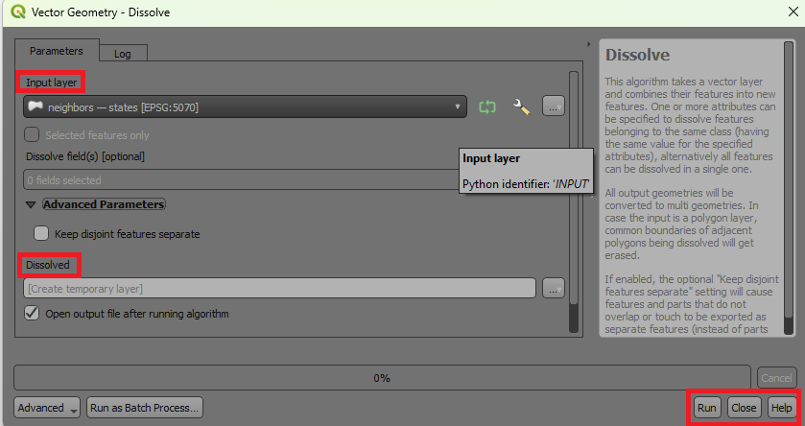

1. **Run the Tool**, click **Run** to perform the dissolve operation.
2. **Difference**

The **Difference** tool removes the intersecting areas of one layer (input layer) using another layer (overlay layer) as a "cookie cutter." The result is a new layer containing only the non-overlapping portions of the input layer.

**Applications of Difference**

* **Map Exclusion Areas**: Identify areas that fall outside of a restricted or protected zone.
* **Environmental Studies**: Remove developed areas from natural habitat layers.
* **Planning and Development**: Identify land available for development by subtracting existing infrastructure.

**How to Perform Difference in QGIS**

**Steps to Use the Difference Tool**

1. **Open the Difference Tool**: Go to ***Vector > Geoprocessing Tools > Difference***. Alternatively, use the **Processing Toolbox** (Difference).
2. **Configure Difference Parameters**:
   * **Input Layer**: Select the layer from which you want to subtract.
   * **Overlay Layer**: Select the layer to use as the subtraction or "cutting" layer.
   * **Output Layer**: Specify the name and location of the resulting layer (if not saving as temporary).

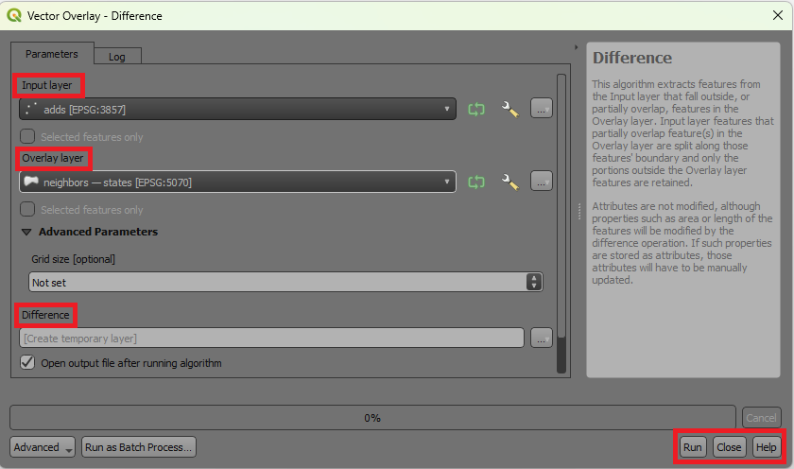

1. **Run the Tool**, click **Run** to execute the operation.

## Raster analysis

1. Raster calculator

The **Raster Calculator** in QGIS is a powerful tool used for mathematical and logical operations on raster datasets. It enables the creation of new raster layers by performing calculations on existing raster data.

The Raster Calculator allows you to:

* Perform mathematical operations (e.g., addition, subtraction, multiplication) on raster layers.
* Create **derived datasets** such as slope, aspect, normalized indices, or suitability maps.
* Apply logical conditions to **extract** or **classify** specific data values.

**Applications of the Raster Calculator**

* **Environmental Analysis**, calculate vegetation indices (e.g., NDVI).
* **Hydrology,** create flow accumulation maps or threshold areas for water runoff.
* **Land Use Classification**, reclassify raster values into new categories.
* **Suitability Analysis**, combine multiple rasters using **weighted** formulas.

**Steps to Open and Use the Raster Calculator**

1. **Open the Raster Calculator**. Go to ***Raster > Raster Calculator***. Alternatively, find it in the **Processing Toolbox** (Raster Calculator).
2. **Set Input Layers**. Select the raster layers you want to include in the calculation. These should be loaded into the **Layers Panel**.
3. **Build the Expression**:
   * Use the provided fields and operators to create a mathematical or logical expression.
   * Example expressions:
     + **Simple Arithmetic**: Combine layers using basic math.  
       
     + **Normalized Difference**: Calculate indices like NDVI:  
       
     + **Conditional Statement**: Classify or extract values.  
       
     + Mathematical Functions.

**Trigonometric Functions**: Apply trigonometric operations to raster values.



**Logarithmic Functions**: Compute the natural logarithm of raster values.



**Power Functions**: Raise raster values to a power for scaling or transformation. 

1. **Set Output Parameters**:
   * Specify the name and location of the output raster layer.
   * Choose the output CRS (default is the CRS of the input layers).
2. **Run the Calculation**:
   * Click **OK** to generate the output raster layer.

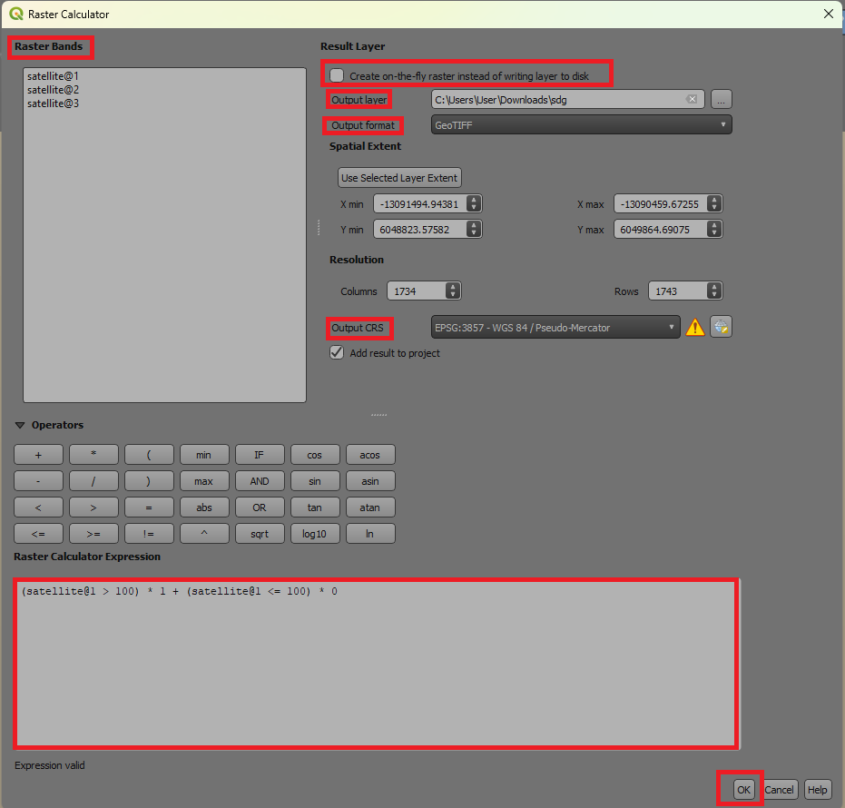

1. **Masking**

**Masking** is a raster analysis technique used to isolate or extract specific parts of a raster dataset by applying a mask layer. This process helps focus on **areas of interest** while ignoring irrelevant data. Masking involves using a **vector** or **raster** mask to "cut out" or "hide" unwanted parts of a raster dataset. The output raster retains values only in the masked area, with the rest of the **cells** typically set to **NoData**.

**Applications of Masking**

* **Environmental Studies**: Extract areas of interest, such as forests within a protected zone.
* **Hydrology**: Isolate water bodies or watersheds for further analysis.
* **Land Use Analysis**: Focus on specific land use types within a region.
* **Map Production**: Create clean outputs by removing extraneous data.

**How to Perform Masking in QGIS**

**Method 1: Using the Raster Mask Tool**

1. **Open the Mask Tool**. Go to ***Raster > Extraction > Clip Raster by Mask Layer***. Alternatively, use the **Processing Toolbox** and search **Clip Raster by Mask Layer**.

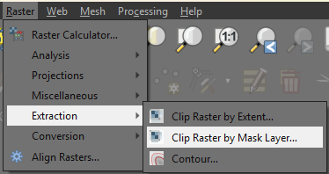

1. **Configure Masking Parameters**:
   * **Input Layer**: Select the raster to be masked (e.g., elevation data).
   * **Mask Layer**: Select the vector or raster layer to use as the mask.
   * **Clipping Extent**: Define whether to clip to the extent of the mask layer.
   * **NoData Value**: Set the value for areas outside the mask (default is NoData).
   * **Output CRS**: Ensure it matches the input layer's CRS.
2. **Run the Tool**: Click **Run** to execute the masking operation.

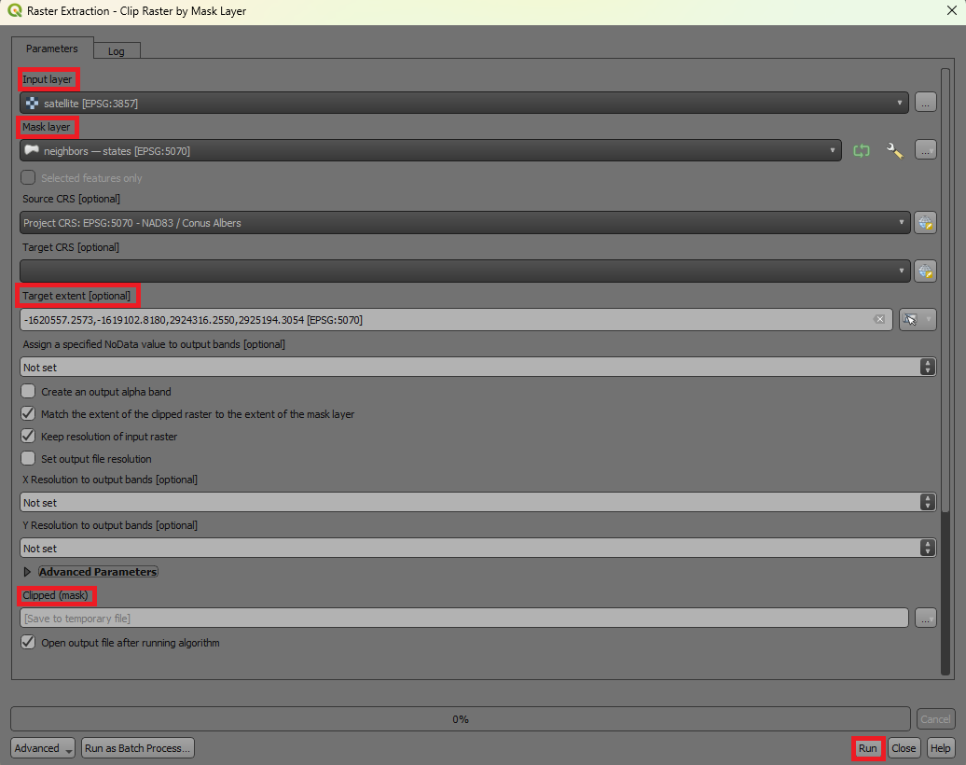

**Method 2: Using Raster Calculator**

You can create a mask using logical expressions in the **Raster Calculator**.

1. Open the **Raster Calculator**.
2. Use a logical condition to define the mask.

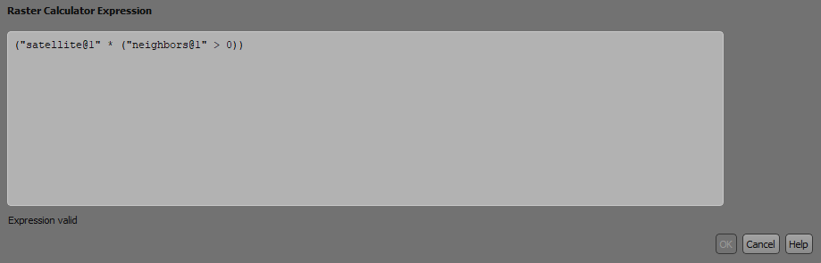

This multiplies the raster by the mask layer, retaining values only where the mask is greater than 0.

1. Save the output raster in an appropriate format.

## Field Calculator

The **Field Calculator** is a powerful tool in QGIS used to create or update attribute data in vector layers. It allows you to perform calculations, derive new values, and manipulate existing fields using mathematical, logical, and string operations.

**Accessing the Field Calculator**

1. Open the **Attribute Table**: Right-click the layer in the ***Layers Panel > Open Attribute Table***.
2. Enable editing mode: Click the **Toggle Editing Mode** button 
3. Open the Field Calculator: Click the **Field Calculator** icon  in the Attribute Table toolbar.

**Creating or Updating Fields**

**Options in the Field Calculator**

1. **Create a New Field**: Add a new column to the attribute table with the calculated values. Then specify the field name, field type (e.g., Integer, Decimal, Text), and length.
2. **Update Existing Field**: Modify the values in an existing column without creating a new field.

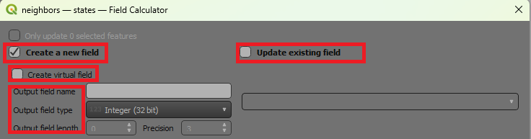

**3. Common Field Calculator Operations**

1. **Mathematical Calculations.** Perform arithmetic operations on numeric fields such as calculating area in square kilometers.



1. **Conditional Statements.** Use logical conditions to assign values based on criteria e.g. classify population.

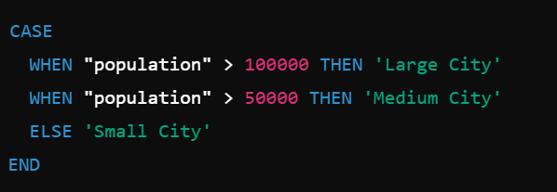

1. **String Operations** toManipulate text fields.

* Example 1: Combine two fields into one.

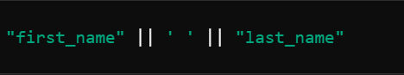

* Example 2: Extract a substring.

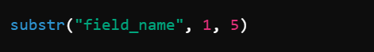

**D. Geometry-Based Calculations** Calculate spatial properties of features

Example 1: Perimeter of polygons.



Example 2: Distance from a point to another layer.

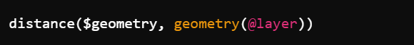

**E. Data Conversion**

* Convert data types or formats.
* Example: Convert numeric field to text.



# **Creating spatial data (Layers)**

## Creating new shapefiles/layers

QGIS provides tools to create new spatial datasets, such as shapefiles or other vector layers, for points, lines, and polygons.

**1.Follow the following steps to create a New Shapefile or Layer**

1. Open the layer creation dialog by going to ***Layer > Create Layer > New Shapefile Layer****.* 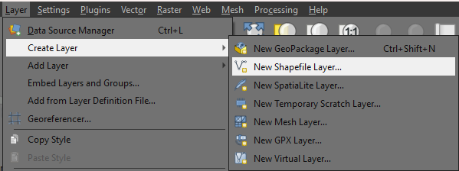
2. **Configure Layer Properties**
   * **File Name**: Click Browse to save the shapefile and name it.
   * **Geometry Type**: Select the type of layer to create:
     + **Point**: For locations like cities or landmarks.
     + **Line**: For linear features like roads or rivers.
     + **Polygon**: For areas like parcels or lakes.
   * **Coordinate Reference System (CRS)**: Choose an appropriate CRS (e.g., WGS 84 - EPSG:4326 for global data).
   * **Fields**: Add attribute fields to store data for each feature:
     + Click the **Add to Fields List** button.
     + Define the **Field Name**, **Type** (e.g., Text, Integer), and **Length**.
3. **Click OK**: A new empty shapefile layer will appear in the **Layers Panel**.

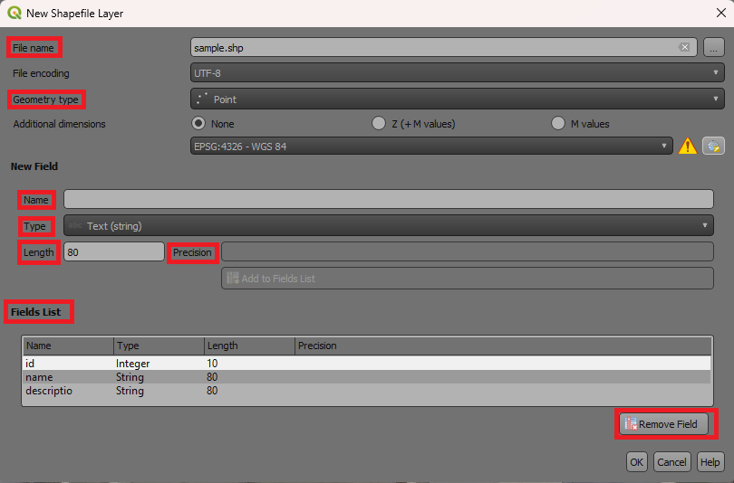

## Layer editing

**Adding Features to the Layer**

Once the new layer is created, features can be added by digitizing. Enable Toggle Editing by ***Right clicking the layer > Toggle Editing***.

**Add Features**

1. Select the **Add Feature** tool  from the toolbar.
2. Click on the map to draw the geometry
   * **Points**: Click once to place a point.
   * **Lines**: Click to add vertices, and right-click to finish the line.
   * **Polygons**: Click to add vertices, and right-click to close the polygon.
3. **Add Attributes**:
   * After completing the geometry, a dialog will appear to enter attribute data.
   * Fill in the fields and click **OK**.

Save Edits byclicking the **Save Layer Edits** button  in the toolbar to save your work.

**Modifying Features**

1. Use the **Vertex Tool ** to:
   * Move existing vertices.
   * Add new vertices (click on a segment).
   * Delete vertices (select and press delete).
2. Use the **Move Feature Tool** to reposition entire features.

**C. Splitting Features**

* Select the **Split Features** tool to divide polygons or lines into smaller parts.

**D. Merging Features**

* Select multiple features > Right-click > Merge Selected Features.
* Enter new attribute data for the merged feature.

**E. Deleting Features**

* Use the **Delete Selected Features** tool to remove unwanted features.

**4. Advanced Editing Tools**

**Snapping**

* Enable snapping to ensure new features align with existing ones:
  + Go to Settings > Snapping Options.
  + Set snapping to **Vertex** or **Edge** for precise placement.

**Modify Features**

* **Move Feature Tool**: Move an existing point, line, or polygon.
* **Vertex Tool**: Edit individual vertices of a line or polygon.

**Merge or Split Features**

* **Merge Features**: Combine multiple polygons into one.
* **Split Features**: Divide a polygon into smaller parts using the **Split Tool**.

**3. Editing Attributes**

**A. Open Attribute Table**

1. Right-click the layer > Open Attribute Table.
2. Click the **Toggle Editing** button in the attribute table.

**B. Modify Attribute Values**

1. Double-click a cell to edit the value.
2. Use the **Field Calculator** for bulk updates or calculations.

**C. Add or Delete Fields**

1. Add Fields:
   * Click the **New Field** button.
   * Specify field name, type (text, integer, etc.), and length.
2. Delete Fields:
   * Select the field(s) and click the **Delete Field** button.

**4. Topological Editing**

Ensure geometric accuracy and maintain spatial relationships:

1. Enable snapping (Settings > Snapping Options).
   * Set snapping to **Vertex**, **Edge**, or both.
   * Define the snapping tolerance (e.g., pixels or map units).
2. Enable topological editing (Settings > Options > Digitizing).
   * Helps maintain shared boundaries between features during editing.

**5. Advanced Editing Tools**

**A. Reshape Features**

* Use the **Reshape Features** tool to adjust feature boundaries.
* Ideal for extending or trimming lines and polygons.

**B. Simplify Features**

* Use the **Simplify Tool** to reduce the number of vertices in complex geometries.

**C. Offset Curve**

* Create parallel curves for lines, useful for road networks or buffers.

**D. Undo and Redo**

* Use **Ctrl + Z** and **Ctrl + Y** to undo or redo edits during editing.

**6. Saving and Finalizing Edits**

1. Save edits frequently using the **Save Layer Edits** button.
2. Once editing is complete, click **Toggle Editing** to disable editing mode.
   * You’ll be prompted to save or discard changes.

# **Cartography and Map Design**

## Elements of map-making (scale, legend, titles).

Effective map design combines art and science to communicate spatial information clearly and accurately. Maps are composed of essential elements that enhance usability and understanding.

**1. Core Elements of Map-Making**

**A. Scale**

Represents the relationship between map distances and real-world distances.

* **Types of Scale Representations**:
  1. **Graphic Scale**: A bar that visually indicates distances.



* 1. **Verbal Scale**: A textual description (e.g., "1 inch equals 1 mile").
  2. **Fractional Scale**: A ratio (e.g., 1:2500 means 1 unit on the map equals 2500 units in the real world) 
* **Importance**:
  1. Helps users measure distances accurately.
  2. Ensures appropriate zoom levels for different applications.
* **Placement**: Positioned prominently, typically near the map's border.

**B. Legend**

This is a key explaining the symbols, colors, and patterns used on the map.

* **Components**:
  + Symbols for points, lines, and polygons.
  + Descriptions of each symbol's meaning.
* **Design Tips**:
  + Use clear, non-ambiguous symbols.
  + Group related items logically (e.g., land use, water features).
  + Ensure the legend matches the map's symbology exactly.
* **Placement**: Usually in a corner, avoiding overlap with critical map features.

**C. Title**

* **Definition**: A concise statement describing the map's purpose or content.
* **Tips for Titles**:
  + Use descriptive and specific language (e.g., "Population Density of California in 2024").
  + Ensure readability with appropriate font size and style.
  + Avoid clutter; keep it simple and informative.
* **Placement**: Centered at the top or bottom of the map layout.

**D. North Arrow**

* **Definition**: Indicates the orientation of the map relative to geographic north.
* **Tips**:
  + Use a simple, clear design.
  + Place in a corner to avoid obstructing the map content.
* **Importance**:
  + Helps readers understand the map's orientation, especially for navigation or analysis.

**E. Map Frame (Extent)**

* **Definition**: Defines the area covered by the map.
* **Components**:
  + A border that frames the map content.
  + Insets or secondary maps to show broader context or details.
* **Importance**:
  + Ensures spatial focus and highlights the area of interest.

**F. Labels**

* **Definition**: Text or annotations identifying features on the map.
* **Design Tips**:
  + Use a readable font size and style.
  + Avoid overlapping features or other labels.
  + Prioritize important features using size, color, or boldness.

**G. Data Source and Citation**

* **Definition**: Acknowledges the source of the data used to create the map.
* **Importance**:
  + Ensures transparency and credibility.
  + Helps users verify or reuse the data.
* **Placement**: Typically in small text at the bottom of the map.

**H. Graticule or Grid**

* **Definition**: A grid of latitude and longitude lines to indicate geographic coordinates.
* **Tips**:
  + Use for maps requiring precise geographic references.
  + Make the grid subtle to avoid overwhelming the map content.

**2. Advanced Map Elements**

**A. Insets**

* **Definition**: Smaller maps showing additional information or context.
* **Use Cases**:
  + Zoom in on a congested area.
  + Show the location of the main map area within a broader region.
* **Placement**: Typically in a corner or side of the layout.

**B. Symbology**

* **Definition**: The visual representation of spatial features.
* **Design Tips**:
  + Use intuitive colors (e.g., blue for water, green for forests).
  + Ensure visual hierarchy (e.g., larger or bolder symbols for important features).

**C. Annotation**

* **Definition**: Explanatory text or graphics providing additional information about specific features.
* **Placement**: Positioned near the related feature without obstructing other elements.

## Creating professional map layouts.

**Steps to Create a Professional Map Layout in QGIS**

**1. Prepare Your Map in the Main QGIS Window**

1. **Load and Style Layers**: Add the necessary spatial data (e.g., shapefiles, rasters) and apply appropriate symbology (e.g., color ramps, categorized styles).
2. **Set Map Extent**, zoom in/out to focus on the area of interest.
3. Label Features. Add labels for key features using ***Layer Properties > Labels***.
4. **Enable Graticules (Optional)**: Add gridlines for geographic reference under ***View > Decorations > Grid.*** Then set the specifications such as interval and extent***.***

**2. Open the Print Layout**

1. Go to ***Project > New Print Layout***.
2. Name your layout (e.g., "Population Map") and click **OK**.

**3. Add and Customize Map Elements**

**A. Add a Map Frame**

* Use the **Add Map** tool from the toolbar.
* Drag and draw a rectangle to define the map area.
* Adjust the map's position and scale:
  + **Right-click the map > Item Properties**.
  + Set the **Scale** manually or adjust the **Extent** interactively.

**B. Add a Title**

* Use the **Add Label** tool.
* Click on the layout canvas and type your title (e.g., "Population Distribution in 2024").
* Customize the font, size, and style in the **Item Properties** panel.

**C. Add a Legend**

* Use the **Add Legend** tool.
* Place it in a corner of the layout.
* Customize:
  + Exclude unnecessary layers under **Item Properties > Legend Items**.
  + Change font sizes, colors, and spacing for clarity.

**D. Add a Scale Bar**

* Use the **Add Scale Bar** tool.
* Place it near the bottom of the map frame.
* Customize:
  + Choose units (e.g., kilometers, miles).
  + Adjust divisions and styles in the **Item Properties** panel.

**E. Add a North Arrow**

* Use the **Add Picture** tool.
* Choose a north arrow symbol from QGIS’s built-in options or load a custom image.
* Place it in an unobtrusive location, typically a corner.

**F. Add Graticules or Gridlines (Optional)**

* Select the ***map frame > Item Properties > Grid***.
* Enable the grid and configure:
  + **Style**: Solid or dashed lines.
  + **Interval**: Define spacing (e.g., 10° latitude/longitude).
  + **Labels**: Show coordinate values along the grid.

**4. Additional Layout Enhancements**

**A. Add Insets**

* Use the **Add Map** tool to create a smaller map on the layout.
* Position it to show the location of the main map area within a larger region.
* Use ***Item Properties > Lock Layers and Styles*** to fix the inset map's content.

**B. Add Annotations**

* Use the **Add Label** tool for explanatory text, such as descriptions or notes.
* Example: "*Data Source: XYZ Agency*."

**C. Add Borders**

* Add borders to elements like the map frame or legend for a cleaner look. ***Select the item > Item Properties > Frame.***

**D. Use Images or Logos**

* Use the **Add Picture** tool to include organizational logos or thematic images.

**5. Layout Design Principles**

**A. Visual Balance**

* Arrange elements symmetrically for a clean, professional appearance.
* Avoid overcrowding by leaving enough whitespace.

**B. Consistent Style**

* Use uniform fonts, colors, and sizes across elements.
* Ensure symbology matches the legend exactly.

**C. Readability**

* Use large, clear fonts for titles and labels.
* Avoid overlapping text or elements.

**D. Focus**

* Highlight the map content while keeping auxiliary elements (e.g., scale bar, legend) unobtrusive.

## Exporting the Map

1. Click ***Layout > Export as Image, Export as PDF, or Export as SVG***.

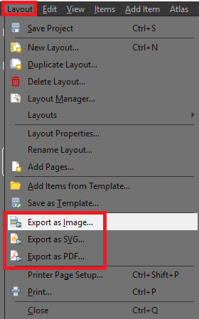

1. Configure export settings:
   * **Resolution**: Set a higher DPI (e.g., 300) for professional-quality prints.
   * **File Format**: Choose based on your purpose (e.g., PDF for reports, PNG for presentations).

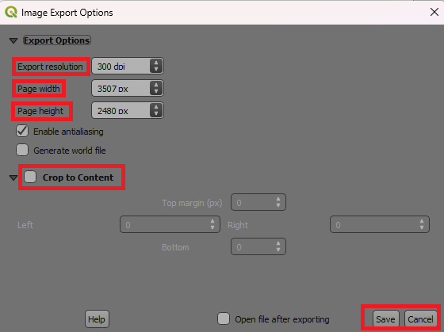

1. Save the file to your desired location.